Olerup SSP®

PHOTO DOCUMENT

Olerup SSP® HLA-A-B-C Combi Tray

Prod. No: 101.702-24/24u
101.702-06/06u
Lot No: 02R
Expiry Date: 2015-February-01

Name:________________Sample ID:_______________

DNA Extract Date:_________ Conc.(ng/ul):_________

Test Date: _________Review Date:_______________

Tested By: _________Reviewed By:_______________

Interpretation:_________________________________

Specificities and sizes of the PCR products of the 24 primer mixes used for HLA-A low resolution SSP typing.

Primer Mix | Size of spec. PCR product¹ | Size of control band² | HLA-A  serology³ | Amplified HLA-A alleles⁴⁻⁶
1^{7,8} | 120 bp, 145bp,  225 bp | 800 bp | A1, A36 | *01:01:01:01-01:04N, 01:06-01:33, 01:35-01:109, 03:18, 03:135, 11:94, 11:112, 36:01-36:05
2⁸ | 210 bp, 255 bp, 365 bp, 415 bp | 800 bp | A2,A19,  A28, A203, A210, A3, A11, A9, A26, A30, A68 | *02:01:01:01-02:01:15, 02:01:17-02:01:19, 02:01:21-02:22:02, 02:24:01-02:35:01, 02:35:03-02:47, 02:49-02:77, 02:78^{w}, 02:79:01-02:97:02, 02:99, 02:101:01-02:128, 02:130-02:358, 03:01:03^{w}, 03:09^{w}, 03:23:01^{w}, 03:89^{w}, 03:108^{w}, 11:06^{w}, 11:18^{w}, 11:121^{w}, 24:28^{w}, 24:89^{w}, 26:03:01-26:03:02^{w}, 26:06^{w}, 26:07:02^{w}, 26:21^{w}, 26:30^{w}, 30:13^{w}, 30:16^{w}, 30:44^{w}, 30:46^{w}, 68:05w, 68:15^{w}, 68:20^{w}, 68:30^{w}
3⁹ | 205 bp, 235 bp | 1070 bp | A1, A3, A11, A32, A34, A36 | *01:12, 01:19, 01:21, 02:338, 03:01:01:01-03:17:01, 03:19-03:74, 03:76-03:94, 03:96-03:134, 03:136-03:143, 11:25, 11:60, 24:92, 32:04, 34:02:01, 34:02:02^{w}, 34:02:03-34:04, 34:07-34:09, 36:02
4 | 190 bp | 800 bp | A1, A3, A11, A30, A36, A68 | *01:01:01:01-01:01:22, 01:01:24-01:04N, 01:06-01:07, 01:09-01:11N, 01:13, 01:16N-01:18N, 01:20-01:29, 01:31N-01:33, 01:35-01:78, 01:80-01:98, 01:100-01:109, 02:78, 02:169, 03:12, 03:18, 03:88, 03:135, 11:01:01-11:27, 11:29-11:52Q, 11:54-11:122, 26:19, 26:72, 30:08, 36:04, 68:13, 68:66
5¹⁵ | 160 bp, 535 bp | 800 bp | A3, A9, A23, A24, A2403, A31, A32 | *01:95, 03:30, 23:01:01-23:51, 24:02:01:01-24:11N, 24:13:01-24:15, 24:17-24:64, 24:66-24:88, 24:90N-24:128, 24:130-24:199, 31:08, 32:05, 32:13, 33:53
6¹¹ | 135 bp, 175 bp, 210 bp | 800 bp | A9, A23, A24, A29, A80 | *23:01:01-23:51, 24:05, 24:13:02, 24:24, 24:199, 29:07, 31:29, 80:01-80:02, B*18:27
7¹² | 175 bp, 205 bp | 1070 bp | A2, A3, A9, A23, A24, A2403, A26 | *02:17:01^{w}-02:17:02^{w}, 23:14:01, 24:02:01:01-24:11N, 24:13:01-24:13:02, 24:17-24:50, 24:54-24:56, 24:58-24:63, 24:66-24:91, 24:93, 24:95-24:113, 24:115-24:137, 24:139-24:187, 24:189-24:199, 26:16, 33:19, 68:45
8 | 165 bp, 200 bp | 800 bp | A2, A3, A10, A11, A25, A26, A28, A32, A34, A66, A68, A69 | *01:51, 02:55, 03:24, 03:50, 11:10, 25:01:01-25:16, 26:01:01-26:06, 26:08-26:15, 26:17-26:18, 26:20-26:43:02, 26:45-26:63, 26:65-26:71N, 26:73-26:74, 29:28, 32:15, 33:51, 34:01:01-34:09, 66:01-66:16, 68:01:01:01-68:88, 69:01
9^{7,10} | 75 bp | 800 bp | A3, A25, A32 | *25:01:01-25:16, 32:01:01-32:02, 32:04, 32:06-32:37, 32:39-32:41
10⁷ | 85 bp | 800 bp | A10, A26 | *01:51, 01:83, 02:146, 26:01:01-26:02, 26:04, 26:07:01-26:18, 26:20, 26:22-26:29, 26:31-26:43:02, 26:45-26:71N, 26:73-26:74, 33:13, 33:48, 68:84
11^{7,8} | 80 bp, 175 bp, 500 bp | 1070 bp | A1, A9, A10, A11, A26, A31, A34, A66 | *01:13, 01:28, 03:63, 03:88, 11:01:01-11:27, 11:29-11:52Q, 11:54-11:122, 24:19, 24:44, 26:03:01-26:03:02, 26:06, 26:21, 34:01:01-34:08, 66:01, 66:04-66:11, 66:13-66:14, 80:02
12⁷ | 125 bp, 185 bp | 800 bp | A3, A10, A25, A26, A31, A34, A43, A66 | *02:309, 03:01:19, 11:11, 25:05-25:06, 26:09, 26:54, 31:03-31:04, 34:01:01-34:09, 43:01, 66:02-66:03, 66:16
13 | 175 bp, 225 bp | 1070 bp | A1, A2, A3, A10, A25, A26, A34, A43, A66 | *01:13, 02:34-02:35:03, 02:56:01-02:56:02, 02:62, 02:103, 02:135, 03:01:01:01-03:01:22, 03:01:24-03:07, 03:09-03:11N, 03:13-03:31, 03:33-03:35, 03:37-03:40, 03:42-03:56, 03:58, 03:60-03:71, 03:73-03:87, 03:90-03:106, 03:109-03:110, 03:112-03:141, 03:143, 25:01:01-25:05, 25:07-25:16, 26:01:01-26:01:20, 26:01:22-26:01:24, 26:02^{w}, 26:03:01-26:03:02, 26:05-26:08, 26:10-26:33, 26:35-26:43:02, 26:45-26:72, 26:74, 30:55, 34:08, 43:01, 66:01, 66:04-66:15, 68:71, 74:13
14⁷ | 100 bp, 200 bp, 240 bp | 800 bp | A2, A29 | *02:237, 02:309, 03:95, 26:19, 26:22, 29:01:01:01-29:35, 30:57, 33:13, 33:48, 66:09
15^{7,8,13,14} | 90 bp, 135 bp, 205 bp | 1070 bp | A1, A30 | *01:13, 01:28, 03:43, 03:82, 11:113, 30:01:01-30:04:02, 30:06-30:20, 30:22-30:63, 31:35
16 | 240 bp, 370 bp, 395 bp | 1070 bp | A2, A24, A31, A32 | *02:237, 03:95, 29:14, 31:01:02-31:62, 32:05, 33:53
17 | 140 bp, 180 bp | 1070 bp | A32 | *01:95, 03:43, 03:82, 29:13, 31:35, 32:01:01-32:03, 32:05-32:41, 74:07
18 | 200 bp | 1070 bp | A33, A68 | *02:243, 33:01:01-33:01:06, 33:03:01-33:50, 33:52-33:59, 68:29
19¹² | 160 bp, 200 bp | 800 bp | A74 | *29:19, 74:01-74:15
20¹¹ | 220 bp, 245 bp | 800 bp | A2, A210, A25, A68 | *02:34-02:35:03, 02:46, 02:48, 02:56:01-02:56:02, 02:62, 02:70, 02:78, 02:103, 02:129, 25:05, 26:54, 68:01:01:01-68:88
21 | 240 bp, 375 bp | 800 bp | A2, A26, A28, A68, A69 | *02:55, 02:243, 24:82, 26:22, 33:22, 66:09, 68:29, 69:01
22^{7,12} | 85 bp, 240 bp | 800 bp | A2, A36 | *02:34-02:35:03, 02:46, 02:48, 02:56:01-02:56:02, 02:62, 02:70, 02:78, 02:103, 02:129, 31:62, 36:01-36:05
23^{7,11} | 75 bp, 160 bp, 240 bp, 495 bp | 800 bp | A2, A26, A28, A36, A68, A80 | *02:55, 03:41, 03:63, 03:75, 03:88, 24:18, 26:03:01-26:03:02, 26:05-26:06, 26:21, 26:30, 33:24, 36:02, 68:05, 68:15, 68:20, 80:01
24¹³ | 360 bp | 1070 bp | A10, A26, A31, A66 | *02:135, 02:309, 03:01:19, 25:13, 26:30, 26:65, 31:04, 34:09, 66:02-66:03, 66:12, 66:16

¹Alleles are assigned by the presence of specific PCR product(s). However, the sizes of the specific PCR products may be helpful in the interpretation of HLA-A low resolution SSP typings.
When the primers in a primer mix can give rise to specific PCR products of more than one length this is indicated if the size difference is more than 20 base pairs. Size differences of 20 base pairs or less are not given. For high resolution SSP kits the respective lengths of the specific PCR product(s) of the alleles amplified by these primer mixes are given.
Nonspecific amplifications, i.e. a ladder or a smear of bands, may sometimes be seen. GC-rich primers have a higher tendency of giving rise to nonspecific amplifications than other primers.
PCR fragments longer than the control bands may sometimes be observed. Such bands should be disregarded and do not influence the interpretation of the SSP typings.
PCR fragments migrating faster than the control bands, but slower than a 400 bp fragment may be seen in some gel read-outs. Such bands can be disregarded and do not influence the interpretation of the SSP typings.
Some primers may give rise to primer oligomer artifacts. Sometimes this phenomenon is an inherit feature of the primer pair(s) of a primer mix. More often it is due to other factors such as too low amount of DNA in the PCR reactions, taking too long time in setting up the PCR reactions, working at elevated room temperature or using thermal cyclers that are not pre-heated.
²The internal positive control primer pairs amplify segments of the human growth hormone gene. The two different control primer pairs give rise to either an internal positive control band of 1070 base pairs, for most wells, or a band of 800 base pairs, for some wells.
Well number 1 contains the primer pair giving rise to the shorter, 800 bp, internal positive control band in order to help in the correct orientation of the HLA-A low resolution typing.
In addition, wells 2, 4, 5, 6, 8, 9, 10, 12, 14 and 19 to 23 contain the primer pair giving rise to the shorter, 800 bp, internal positive control band in order to allow kit identification.
In the presence of a specific amplification the intensity of the control band often decreases.
³The serological reactivity of all HLA-A alleles is not known. In this table we use the expert-assigned serological grouping in Tissue Antigens (2009) 73:95-170 and the serological grouping of the sequence-defined allele.
⁴Nucleotide sequence information is available for only exons 2 and 3 of many HLA Class I alleles and for only exon 2 of many HLA Class II alleles and not for other exons or for the introns of these alleles. We assume that unknown sequences in these exons and in the introns are conserved within loci and within allelic groups.
⁴The A*23:14:01 and the A*24:05, 24:13:02, 24:24 and 24:199 alleles will give rise to identical amplification patterns. These five alleles can be separated by the respective high resolution SSP primer sets.
⁶Primer mix 6 will amplify the B*18:27 allele.
⁷Specific PCR fragments shorter than 125 base pairs have a lower intensity and are less sharp than longer PCR bands.
⁸The primer pairs in wells 1, 2, 11 and 15 will in many samples give rise to two or three HLA-specific PCR fragments.
⁹Primer mix 3 may faintly amplify the A*30:04, 30:06, 30:17 and 30:29 alleles.
¹⁰Primer mix 9 may weakly amplify the A*34 alleles.
¹¹Primer mixes 6, 20 and 23 may have a tendency of primer dimer formation.
¹²Primer mix 22 might faintly amplify most A*11 alleles.
¹³Primer mixes 15 and 24 may yield less specific PCR product than the other HLA-A low primer mixes.
¹⁴Primer mix 15 may have tendencies of unspecific amplifications.
¹⁵In primer mix 5, the specific PCR product of 535 base pairs may be difficult to distinguish from the internal control band. The alleles giving rise to a product of this size are the following: A*01:95, 23:09, 23:51, 24:02:06, 24:02:27, 24:08, 24:24, 24:29 , 24:42, 24:67, 24:116, 24:137, 24:140, 24:145, 24:156, 24:171, 24:191, 24:192 and 32:13.
‘w’, might be weakly amplified.

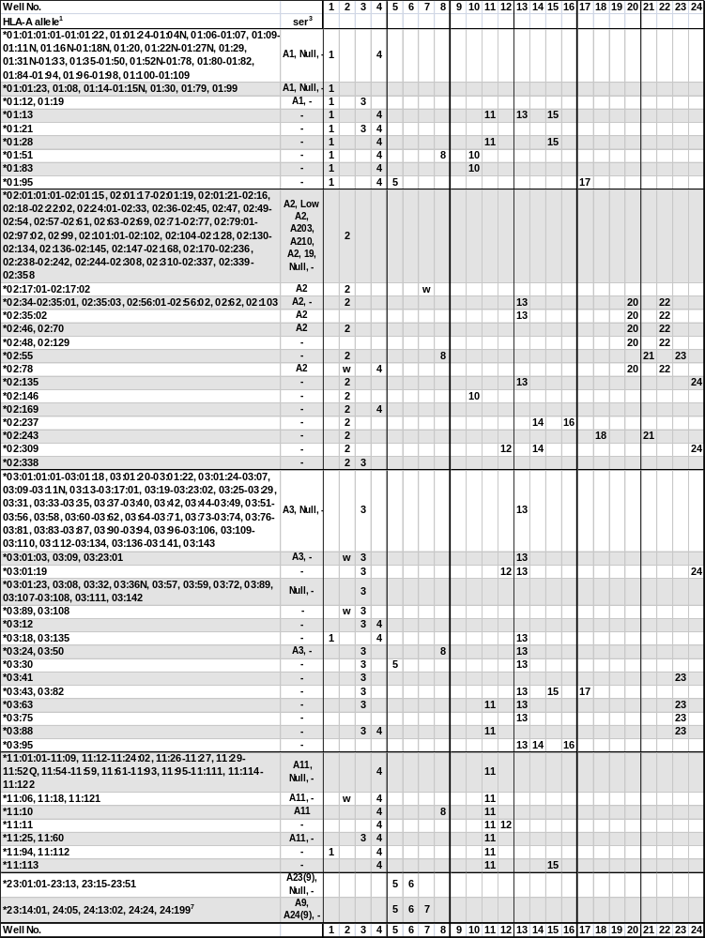
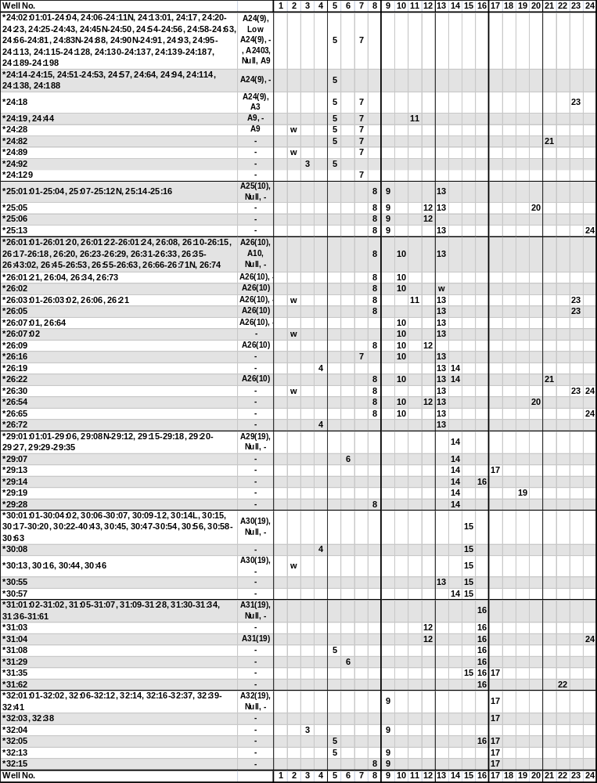
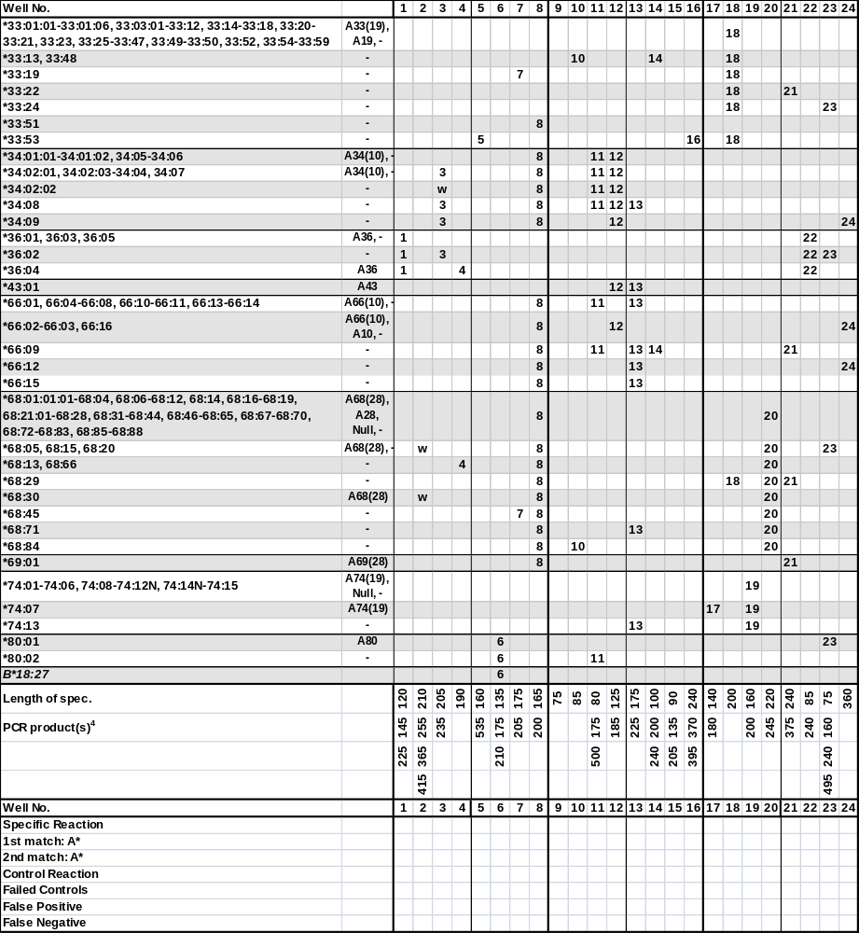

¹The sequence of the A*0105N has been shown to be identical to A*01:04N. The A*01:34N allele has been renamed A*01:01:38L. The A*020116 allele has been renamed to A*02:134. The A*020120 allele has been shown to be identical to A*02:01:18. The sequence of the A*0223 allele has been shown to be identical to A*02:22:01. The sequence of the A*0298 allele has been shown to be identical to A*02:96. The A*02:100 allele has never been assigned. The A*1128 allele has been renamed to A*11:15:02. The A*11:53 allele has been shown to be identical to the corrected sequence of A*11:02:01.The sequence of the A*2401 allele has been shown to be in error. The sequence of the A*2412 allele has been shown to be identical to A*24:08. The A*2416 allele has been renamed to A*31:08. The A*2465 allele has been renamed to A*24:13:02. The A*26:44 allele has been renamed to A*26:43:02.The sequence of the A*3005 allele has been shown to be identical to A*30:04. The A*3021 allele has been renamed to A*30:11:02. The sequence of the A*31011 allele has been shown to be identical to A*31:01:02. The sequence of the A*3302 allele has been shown to be identical to A*33:03:01.
²The A*23:14, 24:05, 24:13:02 and 24:24 alleles will give rise to identical amplification patterns. These four alleles can be separated by the respective high resolution SSP primer sets.
³The serological reactivity of all HLA-A alleles is not known. In this table we use the expert-assigned serological grouping in Tissue Antigens (2009) 73:95-170 and the serological grouping of the sequence-defined allele.
⁴The primer pairs in vials 1, 2, 11 and 15 will in most samples give rise to multiple specific PCR fragments.
‘w’, may be weakly amplified.
Specificities and sizes of the PCR products of the 48 primer mixes used for HLA-B low resolution SSP typing.

Primer Mix | Size of spec. PCR product¹ | Size of control band² | HLA-B  serol.³ | Amplified HLA-B alleles⁴⁻⁶
25^{7,11} | 110 bp | 800 bp | 7, 703, 40, 41, 42, 48, 61 | *07:02:01-07:18:02, 07:20-07:32, 07:34-07:39, 07:41-07:47, 07:49N-07:50, 07:52, 07:54-07:59, 07:61-07:99, 07:101-07:121, 07:123-07:138, 07:140-07:154, 08:79, 15:138, 15:230, 15:241, 37:07, 40:15-40:16, 40:23, 40:32, 40:98, 40:136, 40:158, 40:183, 41:08, 42:05:01-42:05:02, 44:150, 48:05, 48:08, 48:15, C*02:23, C*04:77
26 | 215 bp | 1070 bp | 8, 44 | *08:01:01-08:05, 08:07-08:25, 08:27-08:49, 08:51-08:61, 08:63-08:64, 08:66-08:84, 08:86N-08:88, 15:142, 15:180, 44:49, 51:68
27 | 140 bp,  235 bp | 1070 bp | 7, 8, 13, 15, 35, 4005, 44, 49, 61, 62, 77 | *07:20, 07:24, 07:60, 07:100, 07:131, 08:21, 08:25, 13:01:01-13:04, 13:06-13:08Q, 13:10-13:23, 13:25-13:38, 13:40-13:54, 15:07:01-15:07:02, 15:36^{w}, 15:45, 15:55, 15:68, 15:89^{w}, 15:126, 15:207, 35:05:01-35:05:02, 35:16-35:17, 35:22, 35:30, 35:51, 35:58, 35:72, 35:89, 35:97, 35:113-35:114, 35:125, 35:164, 35:199, 40:05, 40:71, 40:174, 44:08^{w}, 44:54, 44:57^{w}, 44:60, 44:106, 44:110, 44:135, 46:12, 51:64, 53:14, 55:51, 58:18, C*03:05, C*03:25, C*03:27, C*03:143
28^{8,9,16} | 130 bp,  265 bp | 800 bp | 12, 13, 14, 17, 21, 35, 40, 41, 44, 45, 47, 49, 50, 60, 61, 64, 65 | *13:01:01-13:04, 13:06-13:13, 13:15-13:23, 13:25-13:54, 14:01:01-14:04, 14:07N, 14:09, 14:11-14:12, 14:14-14:32, 15:46, 15:53, 15:106, 15:212, 18:44:01, 35:46-35:47, 35:63, 35:154, 40:01:01-40:01:24, 40:07, 40:10:01-40:10:02, 40:14:01-40:16, 40:22N-40:23, 40:25, 40:30-40:34, 40:36, 40:38, 40:42-40:43, 40:45, 40:47-40:49, 40:51-40:55, 40:58-40:63, 40:65-40:67, 40:69, 40:72:01-40:73, 40:76-40:77, 40:79-40:81, 40:84, 40:87:01-40:88, 40:92, 40:100-40:102, 40:106, 40:108, 40:110, 40:112-40:114, 40:116-40:118N, 40:121, 40:123-40:126, 40:128-40:130, 40:132, 40:134-40:136, 40:139-40:141, 40:146-40:147, 40:150-40:156, 40:158, 40:160, 40:163-40:164, 40:166, 40:168, 40:171-40:172, 40:175, 40:178-40:179, 40:182-40:183, 40:186-40:188, 40:191-40:193, 41:01-41:20, 44:02:01:01-44:03:06, 44:03:08-44:05:03, 44:09-44:39, 44:41:01-44:43:02, 44:45-44:56N, 44:58N-44:80, 44:82, 44:84-44:102, 44:104-44:110, 44:112-44:129, 44:132-44:133, 44:135-44:144, 44:146-44:152, 45:01-45:14, 47:01:01:01-47:08, 49:01:01-49:02, 49:04-49:20, 50:01:01-50:02, 50:04-50:06, 50:08-50:16, 57:45, 57:51, C*01:30
29⁹ | 185 bp,  235 bp | 800 bp | 7, 16, 17, 27, 2708, 37, 38, 3901, 3902, 39, 64, 67 | *07:02:32, 14:01:01-14:01:02, 14:07N-14:08, 14:10, 14:12, 14:14, 14:19, 14:26, 14:32, 27:01-27:05:15, 27:05:17-27:06, 27:08-27:10, 27:12-27:13, 27:16-27:18, 27:20, 27:23, 27:26-27:27, 27:29, 27:31, 27:35-27:37, 27:39-27:42, 27:44-27:46, 27:48-27:61, 27:64N-27:69, 27:72-27:75, 27:77-27:80, 27:82-27:89, 37:02, 38:01:01-38:02:02, 38:03, 38:07-38:24, 38:26-38:32, 38:34N-38:40, 39:01:01:01-39:01:01:02L, 39:01:03-39:01:08, 39:01:10-39:02:01, 39:03, 39:05:01-39:09, 39:11, 39:14-39:15, 39:18, 39:19:02, 39:22, 39:24:01-39:39:01, 39:40N-39:44, 39:46-39:48, 39:50-39:62, 39:64-39:71, 39:73, 47:04-47:05, 48:21, 48:26, 67:01:01, 67:03
30 | 190 bp | 800 bp | 14, 35, 38, 39, 65 | *07:28, 08:87, 14:02:01-14:02:02, 14:02:04-14:02:05, 14:03-14:06:02, 14:09, 14:11, 14:13, 14:15-14:18, 14:20, 14:22-14:23, 14:25, 14:27, 14:29-14:31, 15:77, 15:189, 15:233, 35:26, 38:05, 38:33, 39:04, 44:16, 44:37:01-44:37:02, 44:64:01-44:64:02, 44:91, 44:132, 44:150, 52:26, 57:04, A*23:31, A*24:106, C*07:231, C*16:10
31 | 290 bp | 1070 bp | 15, 22, 62, 63, 71, 72, 75, 76, 77, 46 | *15:01:01:01-15:01:03, 15:01:06-15:02:05, 15:03:03-15:08, 15:10:02-15:11:03, 15:11:05-15:15, 15:17:01:01-15:17:02, 15:19-15:21, 15:24-15:28, 15:30-15:36, 15:38:01-15:40, 15:42-15:46, 15:48, 15:50, 15:55-15:58, 15:60, 15:63, 15:65-15:66, 15:70-15:71, 15:73, 15:75-15:79N, 15:81-15:89, 15:92, 15:94N, 15:96-15:97, 15:101-15:102, 15:104-15:107, 15:109-15:113, 15:116-15:118, 15:120-15:122, 15:125-15:126, 15:128-15:129, 15:135-15:150, 15:152, 15:154-15:155, 15:157, 15:159-15:160, 15:162-15:172, 15:174-15:175, 15:177-15:179, 15:181N-15:185, 15:187-15:196, 15:199, 15:201-15:209N, 15:211, 15:213-15:219, 15:223-15:225, 15:227-15:228, 15:230-15:234, 15:236-15:237, 15:239-15:241, 15:244, 46:01:01-46:30, C*07:02:30, C*08:16:02
32 | 165 bp, 220 bp, 330 bp | 1070 bp | 5, 8, 12, 21, 22, 37, 41, 42, 44, 45, 48, 51, 56, 57, 60, 62, 70, 71, 72, 82 | *08:01:01-08:05, 08:08N-08:12:03, 08:15-08:19N, 08:21-08:24, 08:26-08:27, 08:29-08:36, 08:38-08:39, 08:41-08:48, 08:50-08:54, 08:56-08:69, 08:71-08:73, 08:75-08:76, 08:78, 08:80-08:86N, 08:88, 13:46, 15:03:01-15:03:03, 15:09-15:10:02, 15:18:01-15:18:04, 15:23, 15:29, 15:37, 15:46-15:47:02, 15:49,  15:51-15:54, 15:61-15:62, 15:64, 15:69, 15:72, 15:74, 15:80, 15:83, 15:90-15:91, 15:93, 15:98-15:99, 15:103, 15:106, 15:108, 15:114-15:115, 15:119, 15:123-15:124, 15:127, 15:131-15:134, 15:143, 15:151, 15:153, 15:156, 15:158, 15:161, 15:173, 15:176, 15:186, 15:197-15:198, 15:200, 15:210, 15:212, 15:220-15:221, 15:226N, 15:229, 15:235, 15:238, 15:242-15:243, 35:87, 37:12, 38:30, 40:12, 40:136, 41:01-41:03:02, 41:05-41:09, 41:11-41:17, 41:19-41:20, 42:01:01-42:02, 42:04-42:08, 42:10-42:15, 44:14-44:15, 44:18, 44:20, 44:62, 44:100, 45:01-45:14, 51:08, 51:20, 51:36, 51:44N, 51:97, 52:19, 55:20, 55:56, 56:13, 57:09, 82:01-82:03, C*07:46
33^{9,10,12} | 165 bp, 190 bp, 390 bp | 1070 bp | 5, 17, 21, 35, 51, 5102, 5103, 52, 56, 62, 63, 70, 78 | *15:01:02, 15:09, 15:16:01-15:17:02, 15:67, 15:95, 15:162, 15:168, 15:177, 15:196, 15:208, 15:216, 15:222, 15:230, 15:243, 35:01:10, 35:04:02, 40:26, 40:28, 44:62, 49:18, 50:14, 51:01:01-51:01:03, 51:01:05-51:02:03, 51:02:05-51:09:02, 51:11N-51:12, 51:13:02-51:14, 51:16-51:23, 51:24:03-51:24:04, 51:26-51:33, 51:37-51:41N, 51:43-51:44N, 51:46, 51:48-51:61:01, 51:63-51:80, 51:82-51:91, 51:94-51:98N, 51:100-51:130, 52:01:01:01-52:01:04, 52:01:06-52:13, 52:15-52:24, 52:26-52:29, 56:05:01-56:06, 56:21, 58:08:01-58:08:02, 78:01:01-78:07
34 | 180 bp | 800 bp | 13, 22, 55, 60 | *07:78, 13:01:01-13:02:12, 13:07N-13:09, 13:11, 13:14-13:20, 13:22:01-13:23, 13:25, 13:27-13:34, 13:36-13:45, 13:47, 13:49N-13:50, 13:52, 13:54, 40:48, 45:10, 49:07, 54:26, 55:09, 55:22, 55:24
35⁷ | 105 bp,  195 bp | 1070 bp | 8, 12, 27, 38, 39, 3902, 40, 44, 45, 48, 60, 70, 71, 72, 82 | *07:27, 07:50, 08:04, 08:17, 08:54, 15:03:01-15:03:03, 15:47:01-15:47:02, 15:49, 15:54, 15:61-15:62, 15:64, 15:68-15:69, 15:91, 15:98, 15:103, 15:123, 15:127, 15:131-15:132, 15:151, 15:156, 15:158, 15:173, 15:210, 15:220, 15:235, 15:242, 18:37, 27:18, 27:29, 37:28, 38:03, 39:02:01-39:02:02, 39:08, 39:13:01-39:13:02, 39:23, 39:39:01-39:39:02, 39:49, 40:12, 40:46, 40:93, 42:11, 44:10, 44:15, 44:18, 44:40, 44:44, 44:130, 44:140, 45:01, 45:05-45:07, 45:11-45:14, 48:01:01-48:05, 48:07-48:27, 49:20, 50:02, 52:16, 55:18, 82:01-82:03
36 | 280 bp | 1070 bp | 5, 7, 8, 13, 15, 16, 17, 18, 22, 35, 40, 42, 44, 46, 48, 49, 51, 53, 55, 56, 57, 58, 60, 61, 62, 63, 70, 71, 72, 75, 76, 77, 78 | *07:09, 07:11, 07:17, 08:28, 08:35, 08:37, 13:04, 13:10, 13:26, 15:01:01:01-15:01:04, 15:01:06-15:08, 15:11:01-15:16:03, 15:18:01-15:21, 15:23-15:29, 15:31-15:36, 15:38:01-15:40, 15:43-15:44, 15:46-15:47:02, 15:49-15:57, 15:60-15:62, 15:64-15:72, 15:74-15:76, 15:78:01-15:82, 15:84-15:85, 15:87-15:89, 15:91-15:98, 15:101-15:129, 15:131-15:132, 15:134-15:136, 15:138-15:149N, 15:151-15:161, 15:163-15:167, 15:169-15:176, 15:178-15:187, 15:189-15:195, 15:197-15:207, 15:209N-15:215, 15:217-15:223, 15:225-15:228, 15:231-15:232, 15:234-15:242, 15:244, 18:01:01:01-18:15, 18:17N-18:25, 18:27-18:40, 18:42-18:60, 18:62-18:71, 27:41, 35:01:01:01-35:01:31, 35:05:01-35:05:02, 35:07-35:08:05, 35:10-35:11:02, 35:14:01-35:17, 35:19-35:21, 35:23-35:30, 35:32:01-35:32:02, 35:35, 35:37, 35:40N-35:43:01, 35:45-35:54, 35:57-35:58, 35:61-35:64, 35:66-35:69, 35:71-35:72, 35:76-35:80, 35:82, 35:86, 35:89-35:94, 35:97, 35:99-35:105, 35:107-35:108:02, 35:110-35:126, 35:130N-35:135, 35:137-35:148, 35:158-35:159, 35:161, 35:165N-35:166, 35:168, 35:170-35:171, 35:173N-35:178, 35:180, 35:185-35:192, 35:194, 35:196-35:197, 35:200, 39:07, 39:43, 40:03, 40:20, 40:38, 40:52, 40:59-40:60, 40:105, 40:158-40:159, 42:09, 44:17, 44:43:01-44:43:02, 44:144, 45:09, 46:01:01-46:10, 46:12-46:17, 46:19-46:30, 48:02:01-48:02:02, 48:14, 48:23, 48:25, 49:04-49:05, 51:37, 51:45, 51:63, 51:97, 53:01:01-53:03, 53:05-53:06, 53:08:01-53:18, 53:20-53:27, 54:06, 54:09, 54:14, 55:14, 55:23, 55:32, 56:03, 56:09, 56:18, 56:31-56:32, 57:01:01-57:01:13, 57:06, 57:08, 57:10-57:11, 57:13-57:16, 57:18-57:27, 57:29-57:31, 57:33-57:38, 57:40-57:41, 57:43-57:45, 57:47-57:56, 58:01:01-58:02, 58:04-58:07, 58:09-58:19, 58:21-58:26, 58:29-58:33, 58:35-58:36
37 | 195 bp | 1070 bp | 27, 35, 37, 44, 58, 76 | *15:12, 15:14, 15:19, 15:91, 15:131, 15:161, 18:54, 18:56, 35:45, 35:71, 37:01:01-37:09, 37:12-37:13, 37:15-37:21, 37:23-37:28, 37:30N-37:33N, 38:17, 44:17, 44:43:01-44:43:02, 44:144, 45:09, 46:17, 53:22, 58:07, A*24:174
38⁷ | 105 bp, 395 bp, 435 bp | 1070 bp | 5, 7, 15, 41, 42, 62, 63, 70, 71, 75, 77 | *07:04, 07:25, 07:146, 15:09-15:10:02, 15:13:01-15:13:02, 15:16:01-15:18:04, 15:21, 15:23-15:24, 15:37, 15:44, 15:51-15:52, 15:66-15:67, 15:72, 15:80, 15:87, 15:90, 15:93, 15:95, 15:99, 15:108, 15:114-15:115, 15:119, 15:124, 15:133-15:134, 15:153, 15:157, 15:161-15:162, 15:168, 15:176-15:177, 15:186, 15:189, 15:196-15:198, 15:200, 15:208, 15:216, 15:221-15:222, 15:226N, 15:229-15:230, 15:238, 15:243, 40:136, 41:08, 42:05:01-42:05:02
39⁷ | 115 bp,  150 bp | 1070 bp | 18 | *18:01:01:01-18:15, 18:17N-18:28, 18:30-18:71
40⁷ | 80 bp | 1070 bp | 7, 27, 2708, 44, 60 | *07:73, 08:88, 27:01-27:21, 27:23-27:51, 27:53-27:66N, 27:68-27:74, 27:76-27:89, 38:22, 40:46, 40:93, 44:40, 44:44, 44:130
41 | 150 bp | 800 bp | 12, 13, 17, 18, 22, 27, 35, 37, 39, 44, 45, 47, 48, 51, 53, 56, 57, 58, 62, 70, 75, 77, 78 | *08:49, 13:01:01-13:01:06, 13:06-13:07N, 13:12-13:13, 13:17, 13:20, 13:22:01-13:23, 13:25-13:26, 13:28-13:29, 13:36, 13:39, 13:43, 13:50-13:52, 14:10, 15:02:01-15:02:05, 15:13:01-15:13:02, 15:20-15:21, 15:25:01-15:25:03, 15:36, 15:44, 15:62, 15:77, 15:80, 15:85, 15:88-15:89, 15:106, 15:112, 15:121, 15:139, 15:144, 15:154, 15:165, 15:170, 15:194, 15:204, 15:213-15:214, 15:223, 15:240, 18:22, 18:69, 27:19, 27:30, 35:01:01:01-35:04:03, 35:06-35:08:05, 35:10-35:17, 35:19-35:21, 35:23-35:30, 35:33-35:36, 35:38-35:42:02, 35:45-35:50, 35:52, 35:54-35:57, 35:59, 35:61-35:63, 35:65Q, 35:69-35:71, 35:74, 35:76-35:78, 35:80-35:85, 35:90-35:96, 35:98, 35:100-35:101:02, 35:103-35:113, 35:115-35:116, 35:120-35:126, 35:128-35:134N, 35:136-35:150, 35:152-35:173N, 35:175-35:184, 35:186-35:198, 35:200, 37:01:01-37:01:07, 37:03N-37:06, 37:08, 37:10-37:11, 37:13-37:33N, 38:20, 39:42, 40:28, 44:02:01:01-44:14, 44:16-44:17, 44:19N, 44:21-44:30, 44:32-44:40, 44:42-44:46, 44:48-44:52N, 44:55-44:64:02, 44:66-44:98, 44:101-44:105, 44:107-44:134, 44:136-44:137, 44:139-44:152, 48:02:01-48:02:02, 48:25, 51:04, 51:42, 51:46, 51:56:01-51:56:02, 53:01:01-53:13, 53:15-53:27, 55:14, 56:09, 56:11-56:12, 57:01:01-57:01:04, 57:01:06-57:10, 57:12, 57:14-57:20, 57:22-57:30, 57:32-57:46, 57:48-57:57, 58:01:01-58:01:02, 58:01:04-58:01:11, 58:04-58:05, 58:09-58:15, 58:17N, 58:19, 58:21-58:24, 58:28-58:36, 83:01, C*03:102
42 | 135 bp | 1070 bp | 8, 18, 22, 35, 39, 78 | *07:65, 07:134, 08:32, 15:202, 15:239, 18:01:01:01-18:08, 18:10-18:15, 18:17N-18:36, 18:38-18:47, 18:50-18:53, 18:55-18:65, 18:68-18:71, 35:01:01:01-35:03:02, 35:03:04-35:08:04, 35:09:01-35:18, 35:20:01-35:24:02, 35:28-35:45, 35:48, 35:50-35:55, 35:57-35:62, 35:64-35:72, 35:74-35:153, 35:155-35:197, 35:199-35:200, 37:11, 39:19:01-39:19:02, 40:185, 56:06, 78:01:01-78:05, 78:07
43^{7,11} | 60 bp, 245 bp, 400 bp | 1070 bp | 5, 15, 44, 48, 60, 62, 63, 70, 71, 72, 75, 76, 77, 82 | *15:01:01:01-15:01:04, 15:01:06-15:21, 15:23-15:40, 15:42-15:58, 15:60-15:67, 15:69-15:99, 15:102-15:129, 15:131-15:179, 15:181N-15:235, 15:237-15:244, 40:12, 82:01-82:03
44¹¹ | 210 bp | 800 bp | 27, 37 | *07:27, 08:49, 18:54, 37:01:01-37:33N, 38:17
45 | 170 bp | 800 bp | 16, 35, 38, 39, 3901, 3902, 67, 72 | *08:55, 15:69, 15:186, 35:35, 38:01:01-38:09, 38:11-38:21, 38:23-38:29, 38:31-38:35, 38:38-38:40, 39:01:01:01-39:01:01:02L, 39:01:03-39:20, 39:22-39:24:02, 39:26-39:29, 39:31, 39:35, 39:37-39:42, 39:44-39:46, 39:48-39:49, 39:51-39:73, 40:184, 51:101, 58:20, 67:01:01-67:03, C*15:51
46⁷ | 110 bp | 1070 bp | 38 | *38:01:01-38:02:02, 38:03, 38:05, 38:08-38:24, 38:26-38:34N, 38:36-38:40, 52:01:10
47 | 395 bp | 1070 bp | 14, 16, 38, 39, 3901, 64, 65 | *07:69, 07:85, 08:65, 14:01:01-14:20, 14:22-14:32, 38:01:01-38:02:03, 38:04-38:05, 38:08-38:25, 38:27-38:40, 39:01:01:01-39:01:01:02L, 39:01:03-39:01:12, 39:03-39:07, 39:09, 39:11-39:12, 39:14-39:15, 39:18-39:19:02, 39:22, 39:24:01-39:38Q, 39:40N-39:48, 39:50-39:57, 39:59-39:62, 39:64-39:73
48 | 160 bp,  425 bp | 1070 bp | 7, 703, 8, 14, 15, 16, 21, 39, 3901, 3902, 40, 41, 42, 45, 48, 50, 60, 61, 64, 65, 67, 70, 73, 81 | *07:02:01-07:26, 07:28-07:35, 07:37, 07:39-07:64, 07:66-07:80, 07:82-07:148, 07:150-07:154, 08:01:01-08:01:17, 08:04-08:05, 08:07-08:35, 08:37-08:51, 08:53-08:77, 08:79-08:88, 14:01:01-14:02:04, 14:02:06-14:29, 14:31-14:32, 27:14, 27:81, 39:01:01:01-39:01:01:02L, 39:01:03-39:20, 39:22-39:24:01, 39:25N-39:73, 40:01:01-40:01:24, 40:06:01:01-40:06:04, 40:07, 40:09?, 40:11:01?-40:11:02?, 40:14:01?-40:15?, 40:16, 40:18?, 40:21?-40:22N?, 40:23, 40:24?-40:38?, 40:42?-40:43?, 40:44, 40:45?-40:46?, 40:48?-40:50?, 40:51, 40:52?, 40:53, 40:54?-40:58?, 40:59-40:60, 40:61?-40:65?, 40:66, 40:67?-40:69?, 40:70, 40:71?, 40:72:01-40:73, 40:74?, 40:75, 40:77, 40:78?, 40:79, 40:80?-40:82?, 40:83, 40:84?-40:85?, 40:86, 40:87:01?-40:88?, 40:90?-40:92?, 40:93, 40:95?, 40:96, 40:98?-40:102?, 40:103, 40:104?-40:108?, 40:109-40:110, 40:111?-40:116?, 40:118N?-40:121?, 40:123?, 40:124:01, 40:124:02?-40:126?, 40:127, 40:128?-40:130?, 40:131, 40:132?-40:134?, 40:136?-40:137?, 40:138-40:140, 40:141?, 40:145?, 40:146-40:148, 40:149?, 40:150, 40:151?, 40:152-40:153, 40:154?, 40:155N, 40:156?, 40:158?, 40:159, 40:160?, 40:161-40:162, 40:163?-40:164?, 40:165, 40:166?, 40:167, 40:168?-40:171?, 40:172, 40:173?-40:176?, 40:177, 40:178?-40:185?, 40:186, 40:187?, 40:189?, 40:190, 40:191?-40:193?, 41:01-41:20, 42:01:01-42:02, 42:04-42:16, 45:01-45:14, 48:01:01-48:17,  48:19-48:27, 50:01:01-50:02, 50:04-50:16, 51:01:09, 51:01:21, 51:01:25, 51:10, 51:24:02-51:24:04, 54:11, 56:20:02, 67:01:01-67:03, 73:01-73:02, 81:02
49¹³ | 180 bp | 1070 bp | 15, 40, 44, 48, 60, 62, 71 | *15:116, 15:124, 40:01:01-40:01:06, 40:01:08-40:01:17, 40:01:19-40:01:24, 40:07, 40:10:01-40:10:02, 40:12, 40:21-40:23, 40:25, 40:30, 40:33-40:34, 40:36, 40:38, 40:42-40:43, 40:46-40:49, 40:51-40:52, 40:54-40:55, 40:59-40:63, 40:65-40:67, 40:69, 40:73-40:74, 40:76, 40:79, 40:81, 40:84, 40:87:01-40:88, 40:92, 40:100-40:102, 40:106, 40:108, 40:112-40:114, 40:116-40:118N, 40:123-40:126, 40:128, 40:130, 40:132, 40:134-40:135, 40:137-40:141, 40:146-40:147, 40:149-40:156, 40:160, 40:163, 40:166, 40:168, 40:170-40:172, 40:175, 40:178-40:179, 40:182-40:183, 40:185-40:188, 40:191, 40:193, 44:31, 46:06, 48:03:01-48:03:02, 48:17, 48:23, C*03:129
50^{11,17} | 290 bp, 465 bp | 1070 bp | 21, 4005, 41, 50, 60, 61 | *13:02:06, 13:26, 15:16:03, 15:20, 15:85, 15:194, 18:48, 35:46, 40:02:01-40:06:05, 40:08, 40:09?, 40:10:02?-40:11:02?, 40:13, 40:14:01?-40:15?, 40:18?-40:19?, 40:20, 40:22N?, 40:24?-40:38?, 40:39, 40:42?-40:45?, 40:47?-40:50?, 40:52?-40:58?, 40:61?-40:65?, 40:67?-40:69?, 40:70, 40:71?, 40:72:02?, 40:74?-40:76?, 40:78?, 40:80?-40:82?, 40:84?-40:88?, 40:89, 40:90?-40:92?, 40:94, 40:95?-40:96?, 40:97, 40:98?-40:121?, 40:122, 40:123?, 40:124:02?-40:136?, 40:141?, 40:142N-40:144N, 40:145?, 40:148?-40:149?, 40:151?, 40:154?, 40:156?-40:169?, 40:171?, 40:173?-40:176?, 40:178?-40:184?, 40:187?-40:193?, 46:01:07, 47:01:01:01-47:08, 57:05, 58:36
51⁷ | 105 bp | 1070 bp | 7, 8, 22, 41, 42 | *07:04, 07:25, 07:146, 08:01:01-08:05, 08:07-08:12:03, 08:14-08:19N, 08:21-08:24, 08:26-08:39, 08:41-08:54, 08:56-08:69, 08:71-08:78, 08:80-08:88, 35:87, 40:136, 41:01-41:08, 41:10-41:20, 42:01:01-42:02, 42:04-42:07, 42:09-42:16, 55:20
52 | 325 bp | 800 bp | 7, 22, 27, 2708, 35, 42, 45, 46, 54, 55, 56, 67, 73, 78, 81, 82 | *07:02:01-07:02:32, 07:04-07:07, 07:09-07:15, 07:17-07:26, 07:28-07:31, 07:33-07:36, 07:39-07:46, 07:47^{w}, 07:48-07:49N, 07:51-07:68:03, 07:70-07:84, 07:86-07:154, 14:21, 15:76, 15:101, 27:01-27:11, 27:13-27:15, 27:17, 27:19-27:21, 27:24-27:28, 27:30-27:38, 27:40-27:58, 27:60-27:76, 27:78-27:89, 35:76, 35:186, 38:26, 40:166, 42:01:01-42:02, 42:04-42:06, 42:08-42:10, 42:12-42:16, 44:90, 44:97, 45:06, 46:01:01-46:01:07, 46:02^{w}, 46:03-46:30, 54:01:01-54:26, 55:01:01-55:05, 55:07-55:17, 55:19-55:56, 56:01:01-56:16, 56:18-56:22, 56:24-56:32, 56:34-56:35, 67:01:01-67:03, 73:01-73:02, 81:01-81:05, 82:01-82:03, 83:01
53⁷ | 115 bp, 195 bp, 225 bp, 260 bp | 1070 bp | 35, 37, 44, 47, 57 | *08:49, 08:60, 08:76, 08:87, 35:38, 35:45, 35:71, 35:115, 35:169, 37:01:01-37:01:07, 37:03N-37:06, 37:08,  37:10-37:33N, 40:132, 40:178, 42:13, 44:02:01:01-44:14, 44:16-44:17, 44:19N-44:36, 44:38-44:63, 44:65-44:134, 44:136-44:149N, 44:151-44:152, 51:42, 53:22, 57:07, 57:09, 57:24, 83:01, C*15:25
54 | 215 bp | 800 bp | 5, 8, 12, 17, 21, 22, 41, 42, 44, 45, 51, 5102, 5103, 52, 53, 56, 62 | *08:09, 08:84, 13:46, 15:83, 41:01, 41:05-41:07, 41:09, 41:12, 41:14, 41:16-41:17, 41:20, 42:04, 44:06, 44:15, 44:18, 44:20, 44:100, 45:01-45:14, 51:01:01, 51:01:03-51:01:08, 51:01:10-51:02:01, 51:02:03-51:04, 51:06:01-51:07:01, 51:08-51:09:01, 51:10-51:14, 51:16-51:24:04, 51:26-51:46, 51:48-51:53, 51:55-51:77, 51:79-51:88, 51:90-51:92, 51:94-51:102, 51:104-51:115, 51:117-51:118N, 51:120-51:131, 52:01:02, 52:01:04, 52:01:09, 52:02-52:03, 52:06:01-52:06:02, 52:09, 52:19, 52:21, 53:06, 55:20, 55:56, 56:13, 58:08:01
55 | 130 bp,  270 bp | 800 bp | 17, 18, 22, 35, 37, 46, 51, 53, 62, 78 | *14:10, 15:57^{w}, 18:22, 18:69, 35:21, 35:24:01-35:24:02, 35:81, 35:96, 35:109, 35:157, 35:188, 35:190, 37:04:01-37:04:02, 40:28, 46:01:01-46:30, 51:04, 51:46, 51:56:01-51:56:02, 53:02, 53:06, 57:14, 58:09, C*15:39
56^{7,14} | 90 bp,  410 bp | 1070 bp | 15, 22, 27, 35, 47, 54, 55, 56, 78, 81, 82 | *07:65, 27:01^{w}, 27:02:01-27:11, 27:13-27:15, 27:17, 27:19-27:21, 27:24-27:28, 27:30-27:38, 27:40-27:58, 27:60-27:76, 27:78-27:89, 35:76, 35:186, 44:90, 44:97, 47:01:01:01-47:03, 47:06-47:08, 54:01:01-54:26, 55:01:01-55:05, 55:07-55:17, 55:19-55:56, 56:01:01-56:16, 56:18-56:22, 56:24-56:32, 56:34-56:35, 81:01, 82:01-82:03, 83:01
57⁷ | 90 bp,  175 bp | 1070 bp | 15, 27, 35, 48, 60, 62, 75, 77, 81 | *13:36, 15:02:01-15:02:05, 15:08, 15:11:01-15:11:05, 15:13:01-15:13:02, 15:15, 15:21, 15:31, 15:44, 15:55, 15:76^{w}, 15:88-15:89, 15:112, 15:121, 15:139, 15:144, 15:148, 15:170, 15:189, 15:191, 15:194, 15:209N, 15:213-15:215, 15:223, 27:24, 35:46, 40:31, 40:45, 40:80, 48:01:01-48:01:03, 48:04, 48:06-48:07, 48:09, 48:11, 48:15-48:16, 48:18-48:20, 48:22, 48:24, 48:27, 81:01-81:05
58 | 145 bp,  430 bp | 1070 bp | 44, 49, 59, 61 | *40:13, 40:19, 40:109, 40:117, 44:18, 44:25, 44:50, 44:95, 49:01:01-49:01:03, 49:04-49:20, 51:112, 54:12, 56:21, 57:45, 57:51, 59:01:01:01-59:05
59⁷ | 120 bp,  210 bp | 800 bp | 5, 13, 15, 17, 22, 35, 45, 49, 50, 51, 5102, 5103, 52, 55, 56, 62, 63, 78 | *07:78, 07:84, 13:16, 13:31^{w}, 13:48, 15:04^{w}, 15:16:01-15:16:03, 15:42, 15:67, 15:95, 15:137^{w}, 40:95, 40:148, 40:161, 49:01:01, 49:01:03-49:10, 49:12-49:20, 50:01:01-50:02, 50:04-50:11, 50:13-50:16, 51:01:01-51:03, 51:05, 51:07:01-51:09:02, 51:11N-51:14, 51:16-51:24:04, 51:26-51:41N, 51:43-51:44N, 51:48-51:55, 51:57-51:58, 51:60, 51:61:01^{w}, 51:63, 51:65-51:80, 51:82-51:131, 52:01:01:01-52:29, 54:20, 55:01:01-55:01:06, 55:01:08-55:01:09, 55:03, 55:05, 55:09, 55:11, 55:15, 55:17, 55:21^{w}, 55:24-55:25, 55:28-55:29, 55:31, 55:33, 55:36, 55:38, 55:40, 55:44-55:45, 55:52-55:55N, 56:05:01-56:06, 56:21, 56:25, 58:08:01-58:08:02, 78:01:01-78:07
60 | 430 bp | 1070 bp | 5, 17, 27, 44, 51, 5102, 5103, 52, 53, 57, 58, 61 | *18:67, 27:02:01-27:02:02, 27:30, 27:53, 27:57, 27:62, 27:65N, 27:75, 27:77, 27:83, 40:13, 40:19, 40:109, 40:117, 44:06, 44:25, 44:50, 44:95, 51:01:01-51:24:04, 51:26-51:46, 51:48-51:53, 51:55-51:77, 51:79-51:131, 52:01:01:01-52:19, 52:21-52:29, 53:01:01-53:02, 53:04-53:08:02, 53:10, 53:14-53:27, 57:01:01-57:11, 57:13-57:57, 58:01:01-58:02, 58:04-58:16, 58:18-58:36
61 | 145 bp | 1070 bp | 12, 21, 35, 40, 4005, 41, 45, 47, 50, 60, 61 | *07:133, 15:46, 15:53, 15:106, 15:143, 15:212, 18:48, 35:19, 35:47, 35:63, 35:154, 39:69, 40:01:01-40:11:02, 40:14:01-40:16, 40:18, 40:20, 40:22N-40:40, 40:42-40:45, 40:48-40:75, 40:77-40:92, 40:94-40:95, 40:97-40:108, 40:111-40:116, 40:118N-40:136, 40:138-40:156, 40:158-40:184, 40:186-40:187, 40:189-40:193, 41:01-41:04, 41:05?, 41:06-41:20, 44:09, 44:46, 44:75, 44:90, 44:129, 44:131, 45:01-45:14, 47:02, 47:03^{w}, 50:01:01-50:02, 50:04-50:05, 50:07-50:16
62 | 300 bp | 1070 bp | 7, 12, 13, 15, 17, 18, 21, 27, 2708, 35, 37, 38, 39, 3902, 40, 4005, 41, 44, 45, 47, 48, 49, 50, 52, 60, 61, 62, 70, 72, 76 | *07:54, 07:123, 08:17, 08:38, 08:54, 13:01:01-13:04, 13:06, 13:08Q-13:23, 13:25-13:35, 13:37-13:54, 15:01:01:01-15:01:04, 15:01:06-15:01:18, 15:01:20-15:01:28, 15:03:01-15:07:02, 15:12, 15:14, 15:19-15:20, 15:24-15:27:03, 15:30, 15:32-15:36, 15:38:01-15:40, 15:42-15:43, 15:45-15:50, 15:53-15:54, 15:56-15:58, 15:60-15:63, 15:65-15:66, 15:68-15:71, 15:73-15:75, 15:77-15:79N, 15:81-15:87, 15:91-15:92, 15:94N, 15:96-15:98, 15:101-15:107, 15:109-15:111N, 15:113, 15:116-15:118, 15:122-15:123, 15:125-15:129, 15:131-15:132, 15:135-15:138, 15:140-15:142, 15:145-15:147, 15:150-15:152, 15:154-15:160, 15:163-15:167, 15:169, 15:171-15:175, 15:178-15:179, 15:181N-15:185, 15:187-15:188, 15:190N, 15:192-15:193, 15:195, 15:199, 15:201-15:207, 15:210-15:212, 15:217-15:220, 15:224-15:225, 15:227-15:228, 15:231-15:237, 15:239-15:244, 18:12, 27:01-27:21, 27:24-27:89, 35:10, 35:13, 35:16, 35:28, 35:63, 35:69, 35:80, 37:01:01-37:07, 37:09-37:33N, 38:03-38:04, 38:25, 39:02:01-39:02:02, 39:08, 39:13:01-39:13:02, 39:22-39:23, 39:49, 40:01:01-40:07, 40:09-40:16, 40:18-40:24, 40:26-40:40, 40:42-40:67, 40:70-40:105, 40:107-40:165, 40:167-40:193, 41:01-41:20, 42:11, 44:02:01:01-44:02:21, 44:02:23-44:05:03, 44:07-44:11, 44:13-44:152, 45:01-45:14, 47:01:01:01-47:08, 48:01:01-48:05, 48:07-48:15, 48:17-48:27, 49:01:01-49:20, 50:01:01-50:02, 50:04-50:14, 50:16, 52:01:01:01-52:29, 53:17:01-53:17:02, 55:18, 55:34, 55:40, 78:05-78:06
63⁹ | 160 bp,  330 bp | 1070 bp | 22, 44, 45, 47, 54 | *08:87, 44:02:01:01-44:02:24, 44:06, 44:08-44:09, 44:11-44:12, 44:16, 44:19N-44:24, 44:27:01-44:27:02, 44:33-44:34, 44:41:01-44:41:02, 44:44, 44:48-44:49, 44:52N-44:53, 44:55, 44:59, 44:63, 44:66-44:68, 44:71-44:74, 44:80, 44:83-44:84, 44:86-44:87, 44:89-44:91, 44:93, 44:95, 44:97, 44:99-44:102, 44:104, 44:106, 44:112-44:113, 44:116, 44:118-44:119, 44:121, 44:126:01-44:127, 44:131-44:132, 44:137-44:138Q, 44:142Q, 44:145, 44:148-44:149N, 44:151-44:152, 54:01:01, 54:02-54:26, 83:01
64 | 180 bp,  210 bp | 1070 bp | 13, 15, 18, 35, 39, 40, 54, 55, 56, 59, 78 | *07:65, 13:06, 13:53, 15:42, 15:86, 15:224, 18:04, 35:08:05, 35:42:02, 35:60, 35:185, 39:17, 39:63, 40:01:11, 40:58, 45:08, 46:18, 54:01:01-54:02, 54:05N, 54:07-54:08N, 54:10, 54:12-54:13, 54:16-54:25, 55:01:01-55:03, 55:05, 55:07, 55:10-55:12, 55:15-55:16, 55:18-55:19, 55:21, 55:25-55:26, 55:29-55:31, 55:33-55:45, 55:47-55:48, 55:50, 55:52-55:56, 56:05:01, 56:06, 56:10, 56:23, 59:01:01:01-59:01:01:02, 59:05, 78:01:01-78:01:02, 78:02:02-78:03, 78:07, C*15:02:04
65 | 180 bp | 1070 bp | 12, 15, 21, 22, 44, 45, 49, 50, 51, 56, 61, 62, 82 | *13:03, 13:48, 15:73, 40:71, 44:10, 44:15, 44:18, 44:140, 45:01, 45:04-45:07, 45:11-45:14, 46:11, 49:01:01-49:03, 49:06, 49:08-49:17, 49:19N-49:20, 50:01:01-50:02, 50:04-50:08, 50:10-50:13, 50:15-50:16, 51:15, 51:62, 51:106, 52:25, 54:03, 56:01:01-56:02, 56:04, 56:07-56:08, 56:13-56:14, 56:16-56:17, 56:20:01-56:20:02, 56:24-56:30, 56:33-56:35, 59:04, 82:01-82:03, C*03:12, C*03:19, C*03:102
66⁷ | 90 bp,  240 bp | 800 bp | 57 | *55:14, 57:01:01-57:44, 57:46-57:50, 57:52-57:57, 58:36, C*06:72
67^{7,14} | 90 bp | 1070 bp | 5, 13, 15, 17, 39, 55, 56, 58, 60, 61, 62, 71 | *13:11, 15:18:03, 15:73, 15:224, 39:17, 40:48, 40:71, 51:62, 56:02, 56:04, 56:10, 58:01:01-58:02, 58:04-58:35, C*02:06^{w}, C*02:47^{w}
68⁷ | 95 bp | 1070 bp | 8, 18, 22, 35, 37, 38, 39, 44, 51, 5102, 5103, 53, 78 | *07:65^{w}, 07:134^{w}, 08:32, 18:01:01:01-18:11, 18:13-18:15, 18:17N-18:36, 18:38-18:47, 18:49-18:65, 18:67-18:71, 35:01:01:01-35:08:04, 35:09:01-35:09:03, 35:11:01-35:12:03, 35:14:01-35:15, 35:17-35:18, 35:20:01-35:24:02, 35:27, 35:29:01-35:45, 35:48, 35:50-35:62, 35:64-35:68:02, 35:70-35:72, 35:74-35:75, 35:76^{w}, 35:77-35:79, 35:81-35:153, 35:155-35:185, 35:187-35:190, 35:192-35:197, 35:199-35:200, 37:08, 38:06-38:07, 39:19:01-39:19:02, 44:06, 51:01:01-51:24:04, 51:26-51:46, 51:48-51:103, 51:105-51:111, 51:113-51:117, 51:119-51:131, 53:01:01-53:16, 53:18-53:27, 56:06^{w}, 78:01:01-78:04, 78:07
69^{7,11} | 115 bp,  150 bp | 1070 bp | 15, 18,22, 27, 35, 39, 46, 55, 62, 72, 73, 75, 76 | *07:100, 13:31, 13:41, 15:01:01:01-15:01:04, 15:01:06-15:01:16, 15:01:18-15:01:28, 15:04, 15:07:01-15:08, 15:11:01-15:12, 15:14-15:15, 15:19, 15:24, 15:26N-15:28, 15:30, 15:32, 15:34-15:35, 15:38:01-15:38:02, 15:43, 15:45-15:46, 15:50, 15:53-15:54, 15:56-15:58, 15:60, 15:63, 15:66, 15:68, 15:70-15:71, 15:73, 15:75-15:77, 15:79N, 15:81-15:82, 15:85, 15:87, 15:92, 15:94N, 15:96-15:97, 15:101-15:102, 15:104-15:105, 15:109-15:111N, 15:113, 15:117-15:118, 15:120, 15:122, 15:125-15:126, 15:128-15:129, 15:135, 15:137, 15:140, 15:142-15:149N, 15:152, 15:154, 15:157, 15:159-15:160, 15:163-15:167, 15:169, 15:171-15:172, 15:174-15:175, 15:178,  15:180-15:184, 15:187, 15:189-15:193, 15:201-15:203, 15:205-15:207, 15:209N, 15:211-15:212, 15:215, 15:217, 15:225, 15:227-15:228, 15:231-15:234, 15:236, 15:239, 15:241, 15:244, 18:19, 27:25, 27:75, 35:14:01-35:14:02, 35:43:01-35:44, 35:62, 35:67, 35:79, 35:86, 35:102, 35:117, 35:135, 35:163, 35:185, 39:18, 39:36, 44:146, 46:01:01-46:02, 46:04-46:05, 46:07N, 46:09-46:10, 46:12, 46:14-46:17, 46:20, 46:22-46:24, 46:27-46:30, 51:61:01, 52:21, 54:06, 55:21, 56:03, 73:01-73:02, A*26:68, A*68:56, C*02:56, C*06:20, C*12:50
70¹⁵ | 360 bp | 1070 bp | Bw4
71 | 350 bp | 1070 bp | Bw6
72 | 285 bp | 800 bp | 7, 703, 8, 35, 40, 41, 42, 48, 53, 60, 61, 81 | *07:02:01-07:06, 07:08-07:18:02, 07:20-07:32, 07:34-07:39, 07:41-07:52, 07:54-07:59, 07:61-07:76, 07:79-07:83, 07:85-07:99, 07:101-07:121, 07:123-07:138, 07:140-07:154, 08:01:01-08:05, 08:07-08:08N, 08:10-08:11, 08:13-08:15, 08:17-08:83, 08:85-08:88, 35:66, 35:87, 37:07, 40:15-40:16, 40:30-40:32, 40:34, 40:45, 40:59, 40:80, 40:98, 40:137, 40:160, 41:02:01-41:02:04, 41:04, 41:10-41:11, 41:13, 41:18-41:19, 42:01:01-42:02, 42:05:01-42:07, 42:09-42:13, 42:15-42:16, 44:150, 48:01:01-48:01:03, 48:05-48:12, 48:14-48:20, 48:22, 48:27, 53:15, 81:01-81:05

¹Alleles are assigned by the presence of specific PCR product(s). However, the sizes of the specific PCR products may be helpful in the interpretation of HLA-B low resolution SSP typings.
When the primers in a primer mix can give rise to specific PCR products of more than one length this is indicated if the size difference is more than 20 base pairs. Size differences of 20 base pairs or less are not given. For high resolution SSP kits the respective lengths of the specific PCR product(s) of the alleles amplified by these primer mixes are given.
Nonspecific amplifications, i.e. a ladder or a smear of bands, may sometimes be seen. GC-rich primers have a higher tendency of giving rise to nonspecific amplifications than other primers.
PCR fragments longer than the control bands may sometimes be observed. Such bands should be disregarded and do not influence the interpretation of the SSP typings.
PCR fragments migrating faster than the control bands, but slower than a 400 bp fragment may be seen in some gel read-outs. Such bands can be disregarded and do not influence the interpretation of the SSP typings.
Some primers may give rise to primer oligomer artifacts. Sometimes this phenomenon is an inherit feature of the primer pair(s) of a primer mix. More often it is due to other factors such as too low amount of DNA in the PCR reactions, taking too long time in setting up the PCR reactions, working at elevated room temperature or using thermal cyclers that are not pre-heated.
²The internal positive control primer pairs amplify segments of the human growth hormone gene. The two different control primer pairs give rise to either an internal positive control band of 1070 base pairs, for most wells, or a band of 800 base pairs, for some wells.
Well number 25 contains the primer pair giving rise to the shorter, 800 bp, internal positive control band in order to help in the correct orientation of the HLA-B low resolution typing.
In addition, wells number 28 to 30, 34, 41, 44, 45, 52, 54, 55, 59, 66 and 72 contain the primer pair giving rise to the shorter, 800 bp, internal positive control band in order to allow kit identification.
In the presence of a specific amplification the intensity of the control band often decreases.
³The serological reactivity of all HLA-B alleles is not known. In this table we use the expert-assigned serological grouping in Tissue Antigens (2009) 73:95-170 and the serological grouping of the sequence-defined allele.
⁴Nucleotide sequence information is available for only exons 2 and 3 of many HLA Class I alleles and for only exon 2 of many HLA Class II alleles and not for other exons or for the introns of these alleles. We assume that unknown sequences in these exons and in the introns are conserved within loci and within allelic groups.
⁵The B*08:26, 08:50, 08:62, 08:85 and the B*42:07 alleles give rise to identical amplification patterns with the HLA-B low resolution primer set. These alleles can be separated by the respective high resolution primer sets.
The B*13:21, 13:35 and the B*44:135 alleles give rise to identical amplification patterns with the HLA-B low resolution primer set. These alleles can be separated by the respective high resolution primer sets.
The B*14:08 and the B*39:25N, 39:30, 39:32-39:34, 39:47, 39:50 alleles give rise to identical amplification patterns with the HLA-B low resolution primer set. These alleles can be separated by the respective high resolution primer sets.
The B*18:29, 35:32:01-35:32:02, 35:37, 35:53N, 35:64, 35:68:01-35:68:02, 35:99, 35:118-35:119 and 35:174 alleles give rise to identical amplification patterns with the HLA-B low resolution primer set. These alleles can be separated by the respective high resolution primer sets.
The B*41:09 and the B*45:02 and 45:03 alleles give rise to identical amplification patterns with the HLA-B low resolution primer set. These alleles can be separated by the respective high resolution primer sets.
The B*54:01:02, 55:01:07, 55:02:01-55:02:06, 55:07, 55:10, 55:12, 55:16, 55:19, 55:26, 55:30, 55:35, 55:37, 55:39, 55:41-55:43, 55:47-55:48, 55:50 alleles give rise to identical amplification patterns with the HLA-B low resolution primer set. These alleles can be separated by the respective high resolution primer sets.
The B*55:04, 55:08, 55:13, 55:27, 55:46, 55:49 and the B*56:15, 56:19N, 56:22 alleles give rise to identical amplification patterns with the HLA-B low resolution primer set. These alleles can be separated by the respective high resolution primer sets.
The B*55:23 and 55:32 and the B*56:18 and 56:31-56:32 alleles give rise to identical amplification patterns with the HLA-B low resolution primer set. These alleles can be separated by the respective high resolution primer sets.
⁶Due to sharing of sequence motifs, primer mix 25 will amplify the C*02:23 and C*04:77 alleles, primer mix 27 will amplify the C*03:05, C*03:25, C*03:27 and C*03:143 alleles, primer mix 28 will amplify the C*01:30 allele, primer mix 30 will amplify the A*23:31, A*24:106, C*07:231 and C*16:10 alleles, primer mix 31 will amplify the C*07:02:30 and C*08:16:02 alleles, primer mix 32 will amplify the C*07:46 allele, primer mix 37 will amplify the A*24:174 allele, primer mixes 41 and 65 will amplify the C*03:102 allele, primer mix 45 will amplify the C*15:51 allele, primer mix 49 will amplify the C*03:129 allele, primer mix 53 will amplify the C*15:25 allele, primer mix 55 will amplify the C*15:39 allele, primer mix 64 will amplify the C*15:02:04 allele, the C*03:12 and 03:19 alleles will be amplified by primer mix 65, primer mix 66 will amplify the C*06:72allele, primer mix 67 will weakly amplify the C*02:06 and 02:47 alleles and the A*26:68, A*68:56, C*02:56, C*06:20 and C*12:50 alleles will be amplified by primer mix 69.
⁷Specific PCR fragments shorter than 125 base pairs have a lower intensity and are less sharp than longer PCR bands.
⁸Primer mix 28 may yield less specific PCR product than the other HLA-B low resolution primer mixes in B*40, B*41, B*45, B*49 and B*50 alleles.
⁹Primer mixes 28, 29, 33 and 63 may give a lower yield of specific PCR product than the other HLA-B low resolution primer mixes.
¹⁰Primer mix 33 has tendencies of giving rise to nonspecific amplifications.
¹¹Primer mixes 25, 43, 44, 50 and 69 may give rise to a primer oligomer artifact.
¹²The B*57 and B*58 alleles might be faintly amplified by primer mix 33.
¹³The C*17:01 to C*17:04 alleles might be faintly amplified by primer mix 49.
¹⁴Primer mixes 56 and 67 may generate a false positive band of about 800 base pairs. This band should be disregarded when interpreting HLA-B low resolution typings.
¹⁵The Bw4-associated HLA-A specificities A9, A23, A24, A2403, A25 and A32 are not amplified by the primer pair in primer mix 70.
¹⁶Primer mix 28 amplifies the B*15:143, 35:19, 40:170, 44:07 and 50:07 alleles in addition to the alleles specified in the table.
¹⁷Primer mix 50 amplifies the B*37:06:01 allele in addition to the alleles specified in the table.
‘w’, might be weakly amplified.
‘?’, nucleotide sequence information not available for the primer matching sequence.

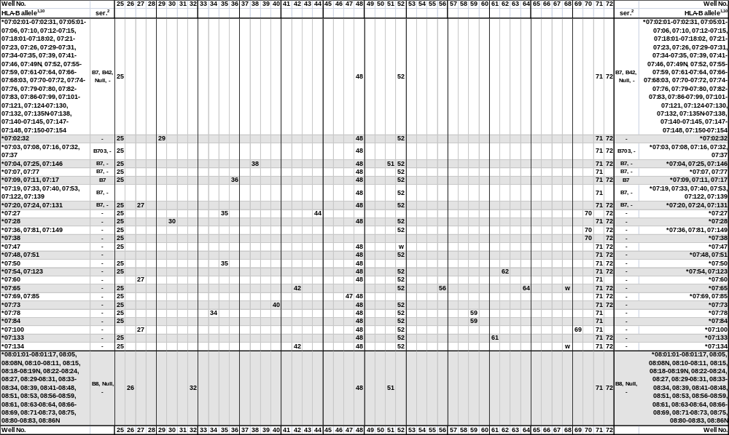
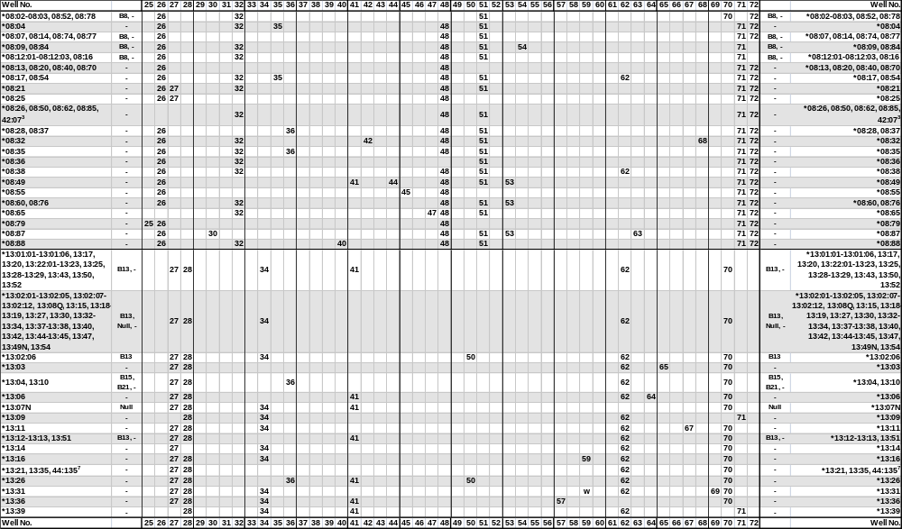
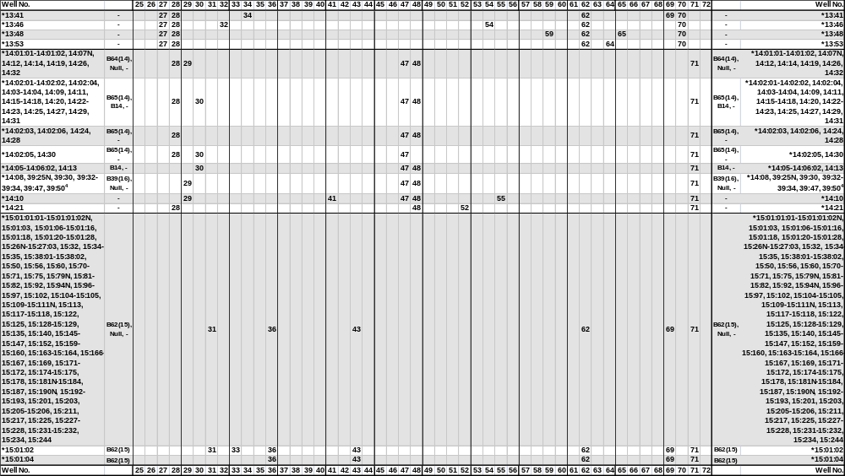
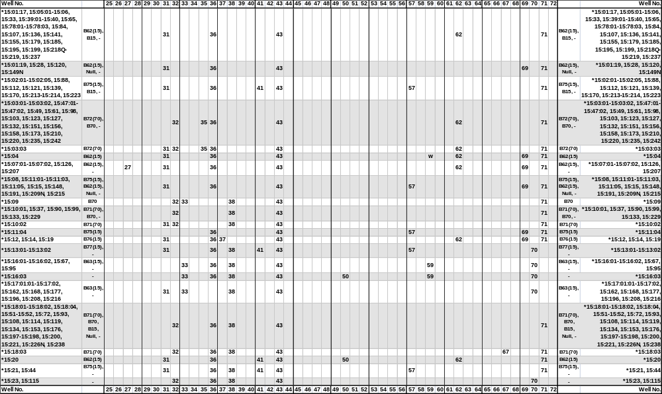
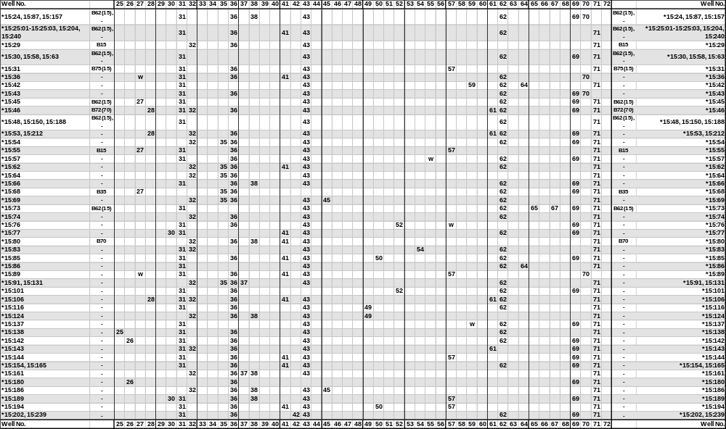
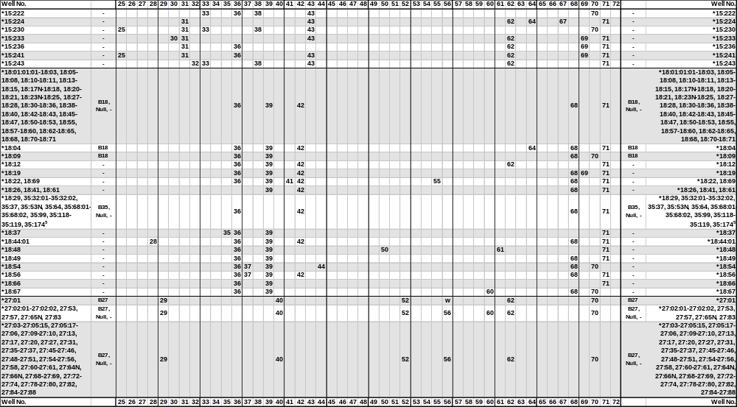
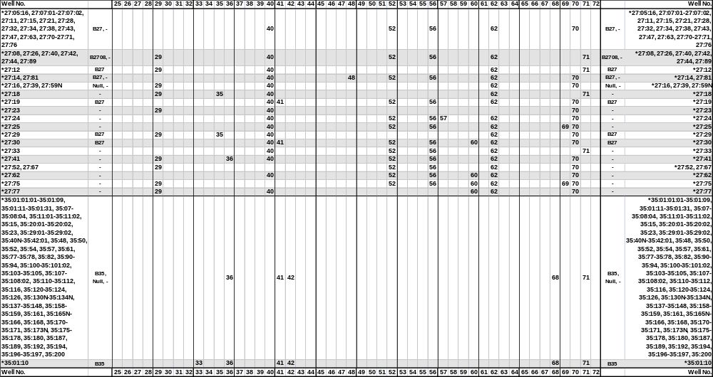
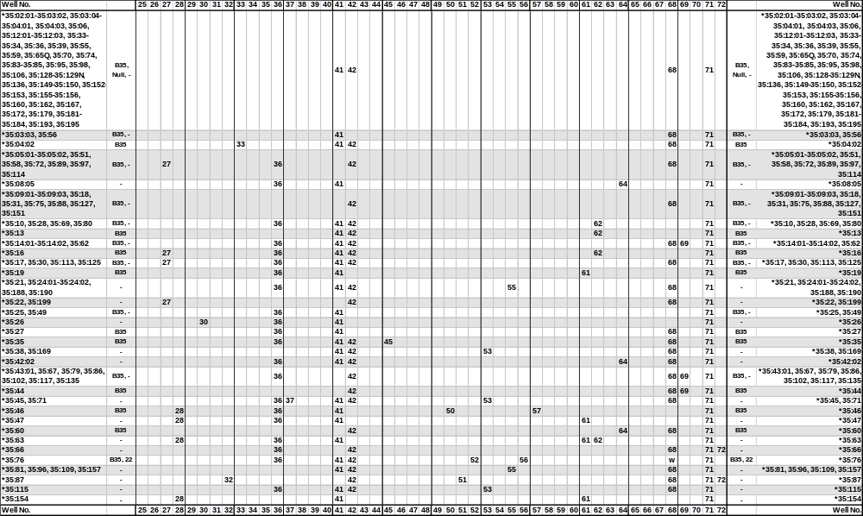
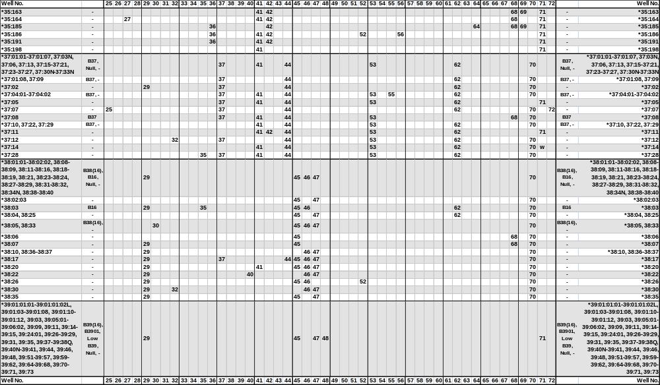
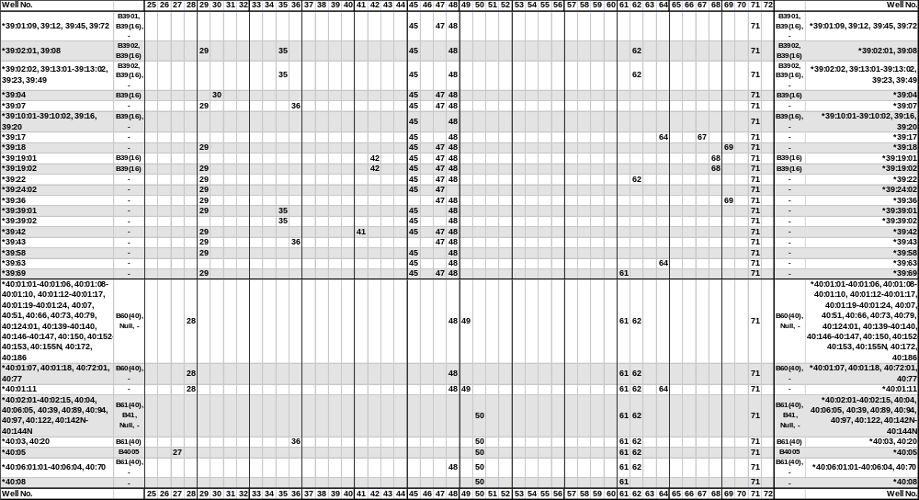
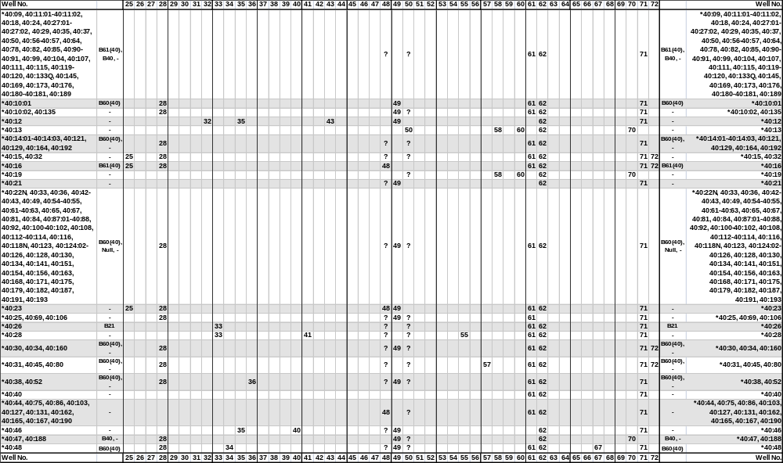
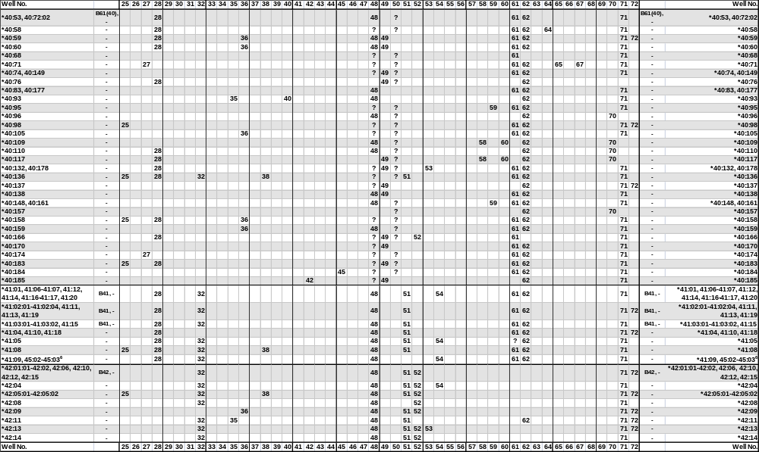
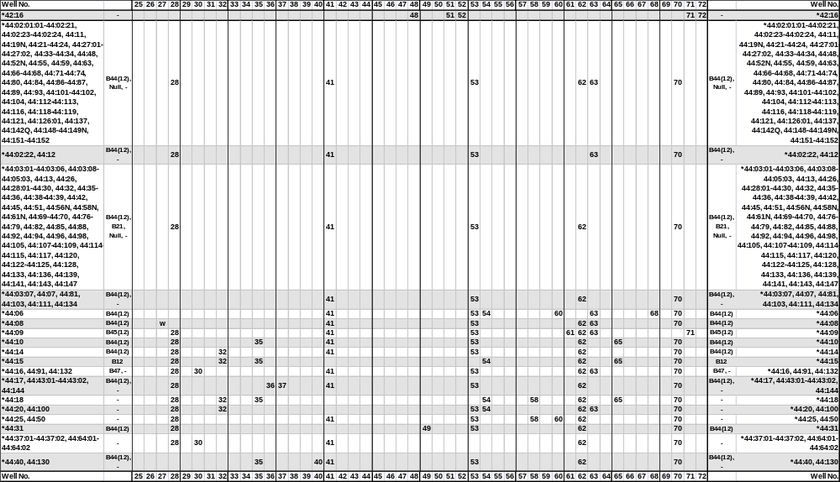
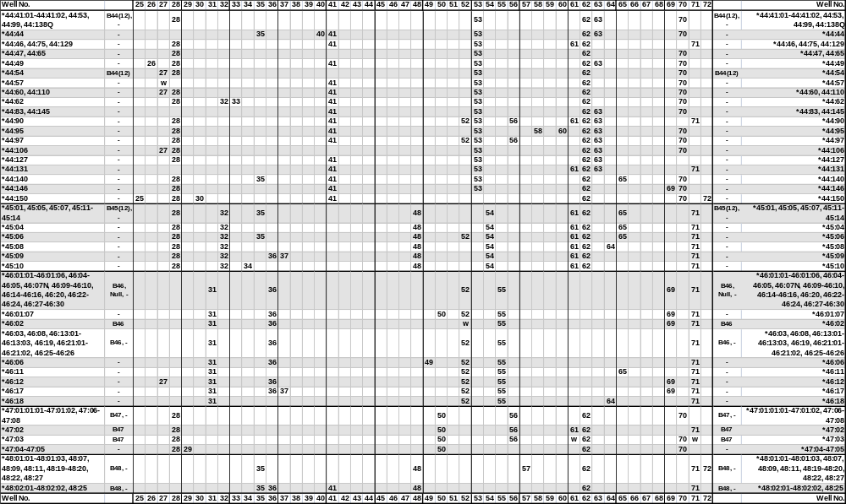
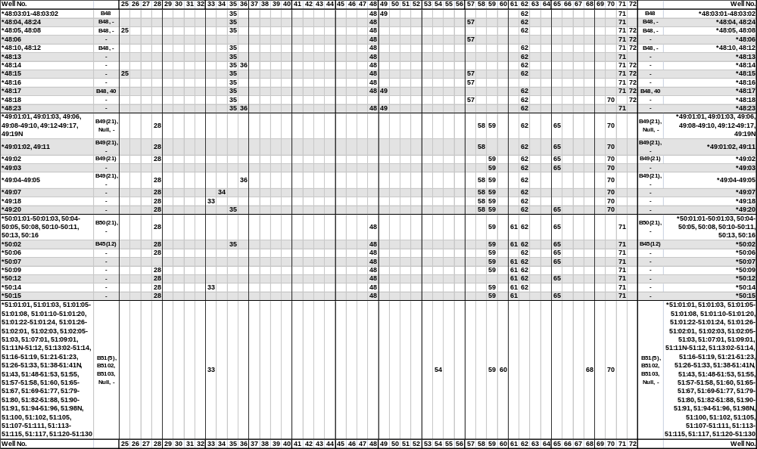
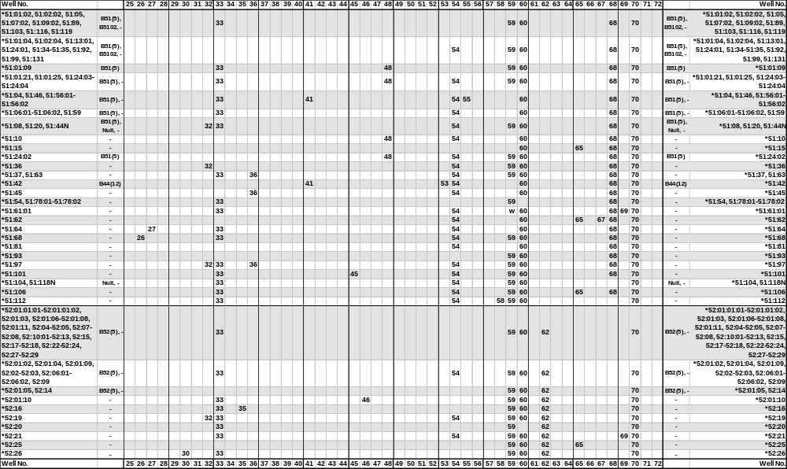
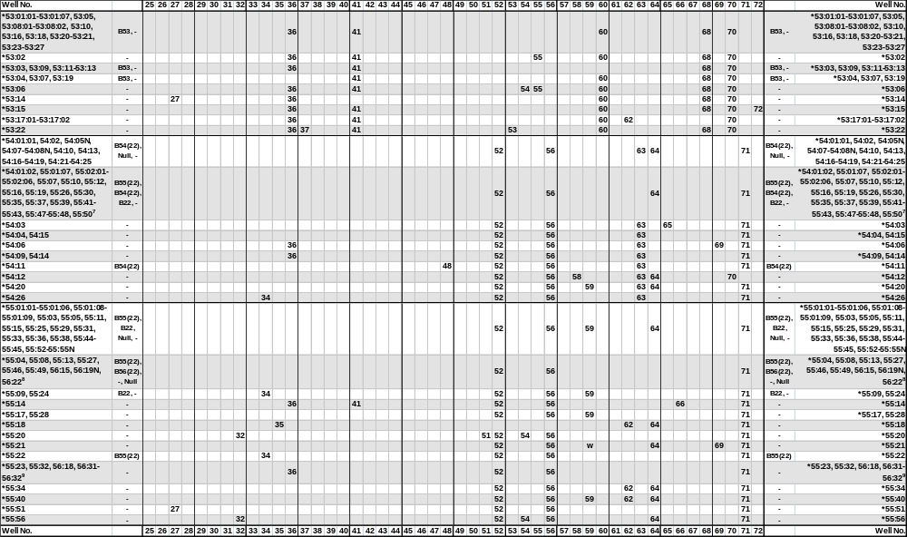
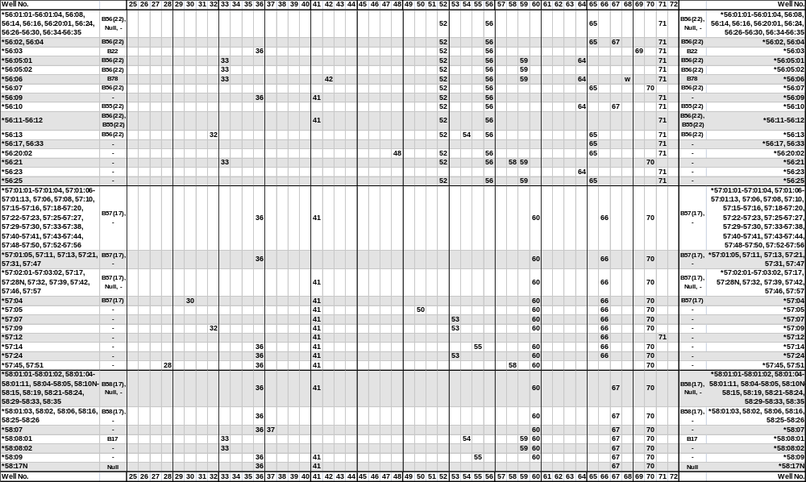

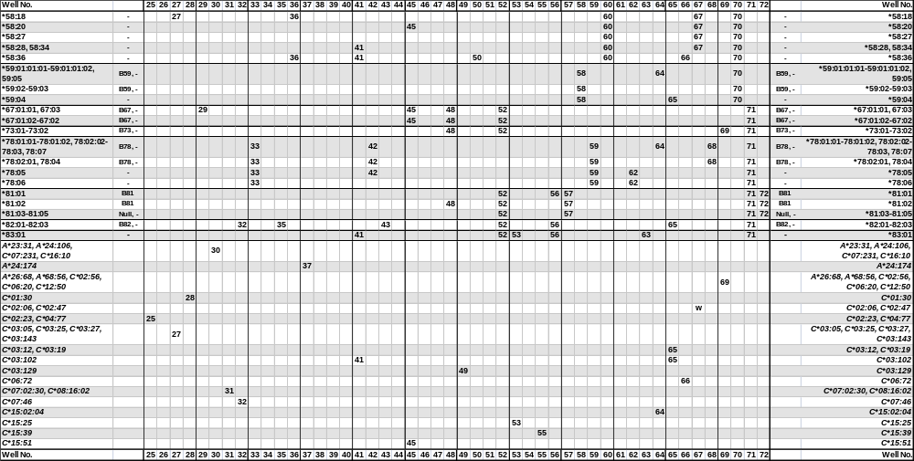

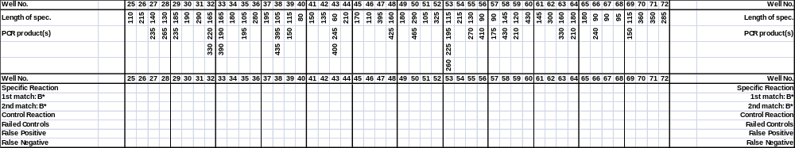
¹The sequence of the B*0701 allele has been shown to be in error.
The sequence of the B*08:06 allele has been shown to be identical to B*08:20.
The sequence of the B*1305 allele has been shown to be identical to B*13:04.
The B*1324 allele has been renamed B*13:22:02
The B*150105 allele has been corrected and renamed B*15:120
The B*1522 allele has been renamed B*35:43.
The sequence of the B*1541 allele has been shown to be identical to B*15:39.
The B*1559 allele has been renamed B*35:44.
The B*15:100 allele has never been assigned.
The sequence of the B*1816 allele has been shown to be identical to B*18:14.
The sequence of the B*27051 allele has been shown to be identical to B*27:05:02.
The sequence of the B*2722 allele has been shown to be identical to the corrected B*27:06 sequence.
The B*3573 allele has been renamed B*35:08:03.
The B*35:43:02 allele has been renamed B*35:185.
The sequence of the B*39012 allele has been shown to be identical to B*39:01:01:01.
The sequence of the B*3921 allele has been shown to be identical to B*39:24.
The sequence of the B*4017 allele has been shown to be identical to B*40:16.
The sequence of the B*4041 allele has been shown to be identical to B*40:40.
The sequence of the B*4203 allele has never been assigned.
The sequence of the B*4401 allele has been shown to be identical to B*44:02:01:01.
The sequence of the B*5003 allele has been shown to be identical to B*50:02.
The sequence of the B*5125 allele has been shown to be identical to B*51:22.
The B*5147 allele has been renamed B*51:09:02.
The sequence of the B*5506 allele has been shown to be identical to B*55:04.
The sequence of the B*5803 allele has never been assigned.
The B*7901 allele has been renamed B*15:18:01.
The B*9530 allele has been renamed B*15:27:02.
²The serological reactivity of all HLA-B alleles is not known. In this table we use the expert-assigned serological grouping in Tissue Antigens (2009) 73:95-170 and the serological grouping of the sequence-defined allele.
³The B*08:26, 08:50 and 08:62 and B*42:07 alleles give rise to identical amplification patterns with the HLA-B low resolution primer set. These alleles can be separated by the respective high resolution primer sets.
⁴The B*14:08 and the B*39:25N, 39:30, 39:32-39:34, 39:47 and 39:50 alleles give rise to identical amplification patterns with the HLA-B low resolution primer set. These alleles can be separated by the respective high resolution primer sets.
⁵The B*18:29 and the B*35:32, 35:37, 35:53N, 35:64, 35:68:01-35:68:02, 35:99, 35:118-35:119 and 35:174 alleles give rise to identical amplification patterns with the HLA-B low resolution primer set. These alleles can be separated by the respective high resolution primer sets.
⁶The B*41:09 and the B*45:02 and 45:03 alleles give rise to identical amplification patterns with the HLA-B low resolution primer set. These alleles can be separated by the respective high resolution primer sets.
⁷The B*54:01:02 and the B*55:01:07-55:02:06, 55:07, 55:10, 55:12, 55:16, 55:19, 55:26, 55:30, 55:35, 55:37, 55:39, 55:41-55:43, 55:47-55:48 and 55:50 alleles give rise to identical amplification patterns with the HLA-B low resolution primer set. These alleles can be separated by the respective high resolution primer sets.
⁸The B*55:04, 55:08, 55:13, 55:27, 55:46 and 55:49 and the B*56:15, 56:19N and 56:22 alleles give rise to identical amplification patterns with the HLA-B low resolution primer set. These alleles can be separated by the respective high resolution primer sets.
⁹The B*55:23 and 55:32 and the B*56:18 and 56:31-56:32 alleles give rise to identical amplification patterns with the HLA-B low resolution primer set. These alleles can be separated by the respective high resolution primer sets.
¹⁰Primer mix 28 amplifies the B*15:143, 35:19, 40:170, 44:07 and 50:07 alleles, and primer mix 50 amplifies the B*37:06:01 allele in addition to the alleles specified in the tables.
‘ser’, serological HLA specificity.
‘w’, might be weakly amplified.
‘?’, nucleotide sequence information not available for the primer matching sequence.

Specificities and sizes of the PCR products of the 23+1 primer mixes used for HLA-C low resolution SSP typing.

Primer Mix | Size of spec. PCR product¹ | Size of control band² | Amplified HLA class I ³⁻⁵ alleles
73 | 155 bp | 800 bp | *01:02:01-01:66, B*54:18
74⁷ | 130 bp, 200 bp,  270 bp, 300 bp | 800 bp | *01:10, 01:43, 02:02:01-02:02:03, 02:02:05-02:40, 02:42-02:56, 04:32, 04:77, 06:08, 07:101, 07:148, 07:161, 08:31, 14:25, 15:42, 16:29, 17:01:01:01-17:06, 17:08-17:11, 18:03
75¹⁴ | 280 bp | 800 bp | *02:02:01-02:02:03, 02:02:05-02:03, 02:04^{w}, 02:05-02:13, 02:14^{w}, 02:15-02:25Q, 02:26:02-02:40, 02:42-02:56, 03:02:01-03:02:09, 03:04:01:01-03:04:25, 03:05-03:10, 03:14-03:17, 03:19, 03:23-03:29, 03:32-03:38:02, 03:40:01-03:42, 03:44-03:48, 03:51, 03:54, 03:57, 03:60, 03:63-03:65, 03:70-03:74, 03:77-03:78, 03:80, 03:82, 03:84, 03:87, 03:89-03:95, 03:98, 03:100-03:101, 03:104-03:111, 03:113-03:115, 03:117-03:118, 03:121N, 03:123, 03:125, 03:128-03:131, 03:134-03:136, 03:138-03:140, 03:143, 03:145-03:146, 04:03, 04:06, 04:16, 04:80, 04:107, 05:58:01, 06:03:01, 07:96, 15:02:01-15:09, 15:10:02-15:11, 15:13, 15:15-15:22, 15:24-15:35, 15:37-15:60, 16:34
76⁸ | 170 bp,275 bp | 1070 bp | *03:02:01-03:04:06, 03:04:08-03:15, 03:17-03:40:02, 03:42-03:57, 03:59-03:79, 03:81-03:85, 03:87-03:93, 03:95-03:98, 03:100-03:109, 03:111-03:112, 03:114-03:146
77 | 280 bp | 800 bp | *03:03:01-03:03:18, 03:11:01-03:13, 03:20N-03:22Q, 03:30-03:31, 03:43:01-03:43:02, 03:49-03:50, 03:52-03:53, 03:55-03:56, 03:58-03:59, 03:61-03:62, 03:66, 03:67^{w}, 03:68-03:69, 03:75-03:76, 03:79, 03:81, 03:83, 03:85-03:86, 03:88, 03:96-03:97, 03:102-03:103, 03:112, 03:116:01, 03:119-03:120, 03:122, 03:124, 03:126-03:127, 03:132-03:133, 03:141-03:142, 15:12
78¹⁴ | 130 bp, 335 bp | 800 bp | *02:02:01-02:02:03, 02:02:05-02:02:12, 02:02:14-02:20, 02:22-02:25Q, 02:27:01-02:38N, 02:40, 02:42-02:44, 02:46-02:56, 04:01:01:01-04:01:27, 04:01:29-04:01:37, 04:03-04:15:03, 04:17-04:20, 04:23-04:41, 04:43-04:102, 04:104-04:112, 05:26, 07:02:09, 07:125, 15:11, 15:36, 16:34
79 | 390 bp, 445 bp | 1070 bp | *05:01:01:01-05:01:18, 05:03-05:74, 08:10, 16:40
80 | 130 bp, 355 bp | 800 bp | *02:06, 02:47, 06:02:01:01-06:02:01:02, 06:02:03-06:16N, 06:18-06:31, 06:33-06:76:01, 12:03:09, 12:15, 15:02:01-15:03, 15:07-15:08, 15:10:01-15:13, 15:15-15:18, 15:21, 15:26, 15:28, 15:31-15:35, 15:37-15:39, 15:41-15:45, 15:47-15:53, 15:56-15:58, 15:60
81⁹ | 245 bp, 425 bp | 800 bp | *07:01:01:01-07:33N, 07:35-07:235
82^{6,10,14} | 115 bp, 165 bp, 265 bp, 390 bp | 800 bp | *01:43, 07:101, 07:148, 07:161, 08:01:01-08:60
83 | 340 bp | 1070 bp | *01:14, 01:59, 02:02:01-02:02:03, 02:02:05-02:11, 02:13-02:26:03, 02:28-02:40, 02:42-02:56, 03:07, 03:15, 03:45, 03:130, 03:140, 04:01:01:01-04:01:37, 04:03-04:10, 04:12-04:20, 04:23-04:28, 04:30-04:35, 04:37-04:54, 04:56-04:112, 05:01:01:01-05:01:18, 05:03-05:74, 06:02:01:01-06:02:01:02, 06:02:03-06:02:11, 06:02:13-06:10, 06:12-06:51, 06:53-06:76:01, 07:07, 07:09, 07:49, 07:76, 07:210, 08:10, 12:04:01-12:05, 12:09, 12:21, 12:33, 12:41, 12:54, 12:60, 14:04, 14:12, 15:02:01-15:06:03, 15:08-15:13, 15:15-15:20, 15:22-15:24, 15:26-15:42, 15:44-15:60, 16:02:01-16:02:09, 16:09, 16:12, 16:19, 16:25, 17:01:01:01-17:11, 18:01-18:05
84^{6,12} | 100 bp, 160 bp,  220 bp | 800 bp | *01:04, 01:21, 12:02:01-12:03:01:02, 12:03:03-12:03:07, 12:03:09-12:03:15, 12:03:17-12:03:19, 12:04:02-12:08, 12:10:01-12:13, 12:14:02-12:18:01, 12:19-12:25, 12:27-12:32, 12:34-12:58, 12:60-12:76, 14:02:08, 16:15:02
85⁶ | 120 bp, 250 bp | 800 bp | *01:21, 02:12, 02:49, 02:55, 04:01:01:01-04:01:37, 04:03-04:09N, 04:12-04:20, 04:23-04:35, 04:37-04:54, 04:56-04:112, 05:42, 05:46, 07:02:09, 07:125, 08:05, 08:21, 08:25, 12:02:01-12:03:03, 12:03:05-12:03:08, 12:03:10-12:03:12, 12:03:13^{w}, 12:03:14-12:03:20, 12:04:02, 12:06-12:08, 12:10:01-12:20, 12:22-12:32, 12:34-12:48, 12:50-12:76, 15:03, 15:16, 15:25, 16:01:01-16:02:09, 16:06-16:28, 16:30N-16:32, 16:34, 16:36-16:39, 16:41, 16:43-16:45, 17:01:04
86¹⁵ | 160 bp, 210 bp | 800 bp | *01:04, 01:09, 02:05, 02:17, 04:42, 06:02:01:01-06:02:01:02, 06:02:03-06:02:15,  06:02:17-06:03:02, 06:07-06:13, 06:15-06:34, 06:36-06:39, 06:41-06:71, 06:73-06:76:01, 07:31, 07:125, 07:177, 12:03:01:01-12:07, 12:11-12:13, 12:15, 12:19, 12:23, 12:25-12:26, 12:28-12:29, 12:31-12:35, 12:37-12:39N, 12:42Q-12:43, 12:45-12:48, 12:50-12:55, 12:57-12:63, 12:65-12:66, 12:70-12:71, 12:75-12:76, 14:15-14:16, 16:04:01, 16:29, 16:33, 16:35, 16:42
87¹⁴ | 130 bp, 255 bp | 1070 bp | *02:02:01^{w}, 02:02:02-02:02:03, 02:02:05-02:13, 02:15-02:26:03, 02:28-02:40, 02:42-02:56, 03:07, 03:10, 03:15, 03:29, 03:45, 03:58, 03:86, 03:94, 03:99, 04:03, 04:06, 04:16, 04:37, 04:80, 04:103, 04:107, 05:01:01:01-05:01:18, 05:03-05:19, 05:21-05:42, 05:44:01-05:74, 06:03:01-06:03:02, 06:76:01, 08:10, 12:04:01-12:05, 12:09, 12:21, 12:33, 12:41, 12:60, 12:72, 15:02:01-15:06:03, 15:08-15:13, 15:15-15:22, 15:24, 15:26-15:35, 15:37-15:42, 15:44-15:60, 16:02:01-16:02:09, 16:09, 16:12, 16:18-16:19, 16:25, 16:37, 17:01:01:01-17:11
88¹³ | 255 bp, 445 bp | 1070 bp | *04:11, 04:29, 04:36, 04:55, 07:64, 12:55, 14:02:01-14:11, 14:13-14:37, 16:40, A*30:62
89^{6,11} | 110 bp, 325 bp | 800 bp | *02:06, 03:81, 04:108, 04:112, 05:36, 07:123, 07:173, 12:08, 12:15, 15:02:01-15:13, 15:15-15:24, 15:26-15:60, 16:20
90¹³ | 180 bp, 210 bp,  240 bp | 1070 bp | *02:13, 02:18, 02:33, 02:49, 04:01:01:01-04:01:22, 04:01:24-04:01:37, 04:03-04:10, 04:12-04:20, 04:23-04:32, 04:34-04:106, 04:108-04:112, 05:17, 05:25, 05:42, 05:55, 05:68, 06:05, 06:31, 07:02:09, 07:31, 07:177, 08:01:01-08:01:05, 08:03:01-08:03:02, 08:06, 08:08-08:11, 08:14, 08:16:01-08:16:02, 08:20-08:22, 08:24, 08:26N, 08:28, 08:36N, 08:38, 08:40-08:42, 08:44, 08:46, 08:50, 08:56-08:60, 12:14:01-12:14:02, 12:28, 12:58, 14:10, 14:15, 15:12, 15:25, 16:01:01-16:02:09, 16:04:01, 16:06-16:39, 16:41-16:42, 16:44-16:45
91^{12,16,17} | 225 bp, 250 bp | 800 bp | *01:60, 04:58, 05:23, 05:62, 08:07, 08:47, 12:14:01-12:14:02, 14:17, 15:25, 17:01:01:01-17:11
92 | 215 bp, 425 bp | 800 bp | *01:02:01-01:03, 01:06-01:08, 01:10-01:20, 01:23-01:34, 01:37N-01:48, 01:51-01:54, 01:56N-01:66, 03:58, 03:86, 03:94, 03:99, 04:37, 05:16, 06:05-06:06, 06:17, 06:31, 07:07, 07:09, 07:49, 07:76, 07:210, 08:12, 12:09, 12:24,  14:02:01-14:05, 14:07N, 14:10-14:14, 14:17-14:27, 14:29-14:37, 16:04:01, 16:29, 16:33, 16:42, 18:01-18:05, B*14:03
93 | 325 bp, 380 bp | 1070 bp | *01:03, 01:24, 01:34, 01:49-01:50, 01:55, 02:22, 03:03:01-03:04:26, 03:06-03:12, 03:14, 03:18-03:24, 03:26, 03:28-03:32, 03:34, 03:37-03:59, 03:61-03:70, 03:72-03:83, 03:85, 03:87-03:88, 03:90-03:93, 03:96, 03:98, 03:100-03:107, 03:109, 03:111-03:120, 03:122-03:131, 03:133-03:134, 03:136-03:138, 03:140-03:145, 04:01:01:01-04:01:15, 04:01:17-04:01:37, 04:03-04:20, 04:24-04:53, 04:55-04:71, 04:73-04:107, 04:109-04:112, 05:01:01:01-05:01:18, 05:03, 05:05-05:21, 05:23-05:74, 06:09, 06:14, 06:35, 06:72, 07:10, 07:28, 07:41, 07:43, 07:184, 07:196, 08:01:01-08:08, 08:10, 08:12-08:47, 08:49-08:60, 12:31, 12:44, 15:02:01-15:13, 15:15-15:21, 15:23-15:36, 15:38-15:54, 15:56-15:57, 15:59-15:60, 16:45, 17:01:01:01-17:11, 18:01-18:05
94¹³ | 135 bp | 1070 bp | *03:02:01-03:04:24, 03:05-03:17, 03:19-03:38:02, 03:40:01-03:66, 03:67^{w}, 03:68-03:98, 03:100-03:136, 03:138-03:143, 03:146, 04:32, 04:77, 06:03:01, 07:96, 14:25, 15:02:10, 15:43, 18:03
95¹⁴ | 160 bp, 235 bp | 1070 bp | *04:14, 04:42, 04:68, 06:02:01:01-06:02:01:02, 06:02:03-06:02:19, 06:04-06:75, 07:01:01:01-07:02:07, 07:02:09-07:02:28, 07:02:30-07:25, 07:27:01-07:32N, 07:35-07:38:02, 07:41-07:63, 07:65-07:91, 07:93-07:95, 07:97-07:138, 07:140-07:151, 07:153-07:155, 07:157-07:176, 07:178-07:209, 07:211-07:222, 07:223^{w}, 07:224-07:235, 12:16, 16:01:01-16:02:09, 16:06-16:28, 16:30N-16:32, 16:34, 16:36-16:39, 16:41, 16:43-16:45, 18:01-18:05, A*24:96, A*24:106, A*24:174, B*08:16, B*46:25
96¹⁸ | Negative control | -

¹Alleles are assigned by the presence of specific PCR product(s). However, the sizes of the specific PCR products may be helpful in the interpretation of HLA-C low resolution SSP typings.
When the primers in a primer mix can give rise to specific PCR products of more than one length this is indicated if the size difference is more than 20 base pairs. Size differences of 20 base pairs or less are not given. For high resolution SSP kits the respective lengths of the specific PCR product(s) of the alleles amplified by these primer mixes are given.
Nonspecific amplifications, i.e. a ladder or a smear of bands, may sometimes be seen. GC-rich primers have a higher tendency of giving rise to nonspecific amplifications than other primers.
PCR fragments longer than the control bands may sometimes be observed. Such bands should be disregarded and do not influence the interpretation of the SSP typings.
PCR fragments migrating faster than the control bands, but slower than a 400 bp fragment may be seen in some gel read-outs. Such bands can be disregarded and do not influence the interpretation of the SSP typings.
Some primers may give rise to primer oligomer artifacts. Sometimes this phenomenon is an inherit feature of the primer pair(s) of a primer mix. More often it is due to other factors such as too low amount of DNA in the PCR reactions, taking too long time in setting up the PCR reactions, working at elevated room temperature or using thermal cyclers that are not pre-heated.
²The internal positive control primer pairs amplify segments of the human growth hormone gene. The two different control primer pairs give rise to either an internal positive control band of 1070 base pairs, for most wells, or a band of 800 base pairs, for some wells.
Well number 73 contains the primer pair giving rise to the shorter, 800 bp, internal positive control band in order to help in the correct orientation of the HLA-C low resolution typing.
In addition, wells number 74, 75, 77, 78, 80 to 82, 84 to 86, 89, 91 and 92 contain the primer pair giving rise to the shorter, 800 bp, internal positive control band in order to allow kit identification.
In the presence of a specific amplification the intensity of the control band often decreases.
³Nucleotide sequence information is available for only exons 2 and 3 of many HLA Class I alleles and for only exon 2 of many HLA Class II alleles and not for other exons or for the introns of these alleles. We assume that unknown sequences in these exons and in the introns are conserved within loci and within allelic groups.
⁴Due to sharing of sequence motifs, primer mix 73 will amplify the B*54:18 allele, primer mix 85 will amplify the B*67:02 allele, primer mix 88 will amplify the A*30:62 allele, primer mix 92 will amplify the B*14:03 allele and primer mix 95 will amplify the A*24:96, A*24:106, A*24:174, B*08:16 and B*46:25 alleles.
⁵The C*01:05, 01:22, 01:35 and 01:36 and the B*54:18 alleles give rise to identical amplification patterns with the HLA-C low resolution primer set. These alleles are separated by the HLA-B low primer set.
The C*12:18:02 and the B*67:02 alleles give rise to identical amplification patterns with the HLA-C low resolution primer set. These alleles are separated by the HLA-B low primer set.
The C*14:06, 14:08-14:09 and 14:28 and the A*30:62 alleles give rise to identical amplification patterns with the HLA-C low resolution primer set. These alleles are separated by the HLA-A low primer set.
⁶Specific PCR fragments shorter than 125 base pairs have a lower intensity and are less sharp than longer PCR bands.
⁷Primer mix 74 will for most C*02 alleles give rise to two specific PCR fragments.
⁸Primer mix 76 will for most C*03 alleles give rise to two specific PCR fragments.
⁹Primer mix 81 will for most C*07 alleles give rise to two specific PCR fragments.
¹⁰Primer mix 82 will for most C*08 alleles give rise to multiple specific PCR fragments.
¹¹Primer mix 89 will for most C*15 alleles give rise to two specific PCR fragments.
¹²Primer mixes 84 and 91 may give rise to unspecific amplification.
¹³Primer mixes 88, 90 and 94 have a tendency of giving rise to primer oligomer artifacts.
¹⁴Primer mixes 75, 78, 82, 87 and 95 may yield less HLA-specific PCR fragments than the other HLA-C low resolution primer mixes.
¹⁵Primer mix 86 might faintly amplify most C*01 and the C*14 alleles.
¹⁶Primer mix 91 might generate a false band of about 500 base pairs. This band should be disregarded when interpreting HLA-C low resolution typings.
¹⁷Primer mix 91 may give rise to weaker positive control bands than the other HLA-C low primer mixes.
¹⁸Primer mix 96 contains a negative control, which will amplify more than 95% of HLA amplicons as well as the amplicons generated by control primer pairs. PCR product sizes range from 75 to 200 base pairs. The PCR product generated by the control primer pair is 430 base pairs.
‘w’, might be weakly amplified.

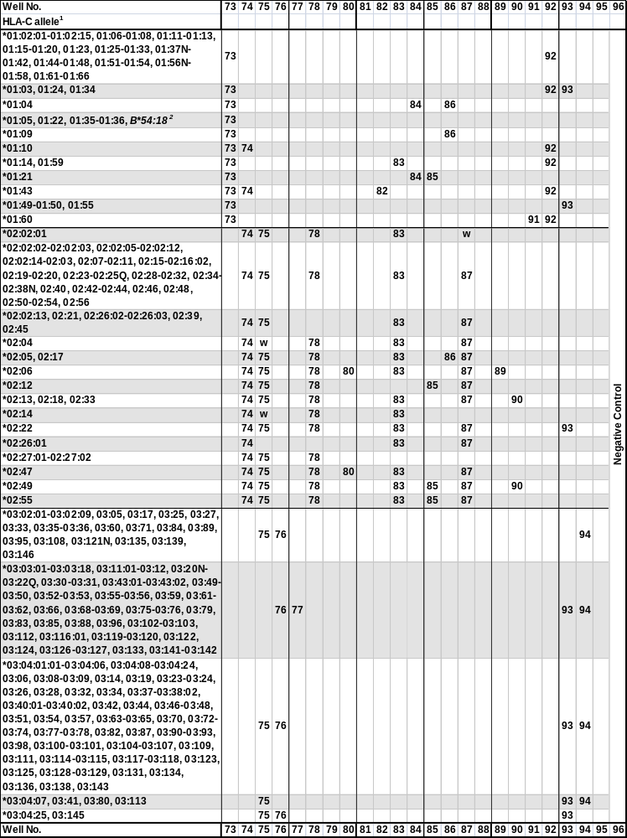
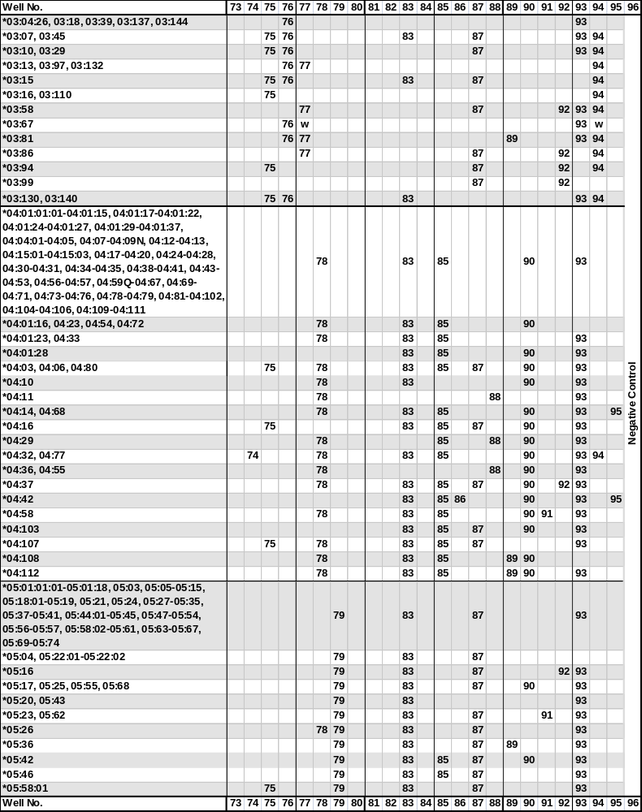
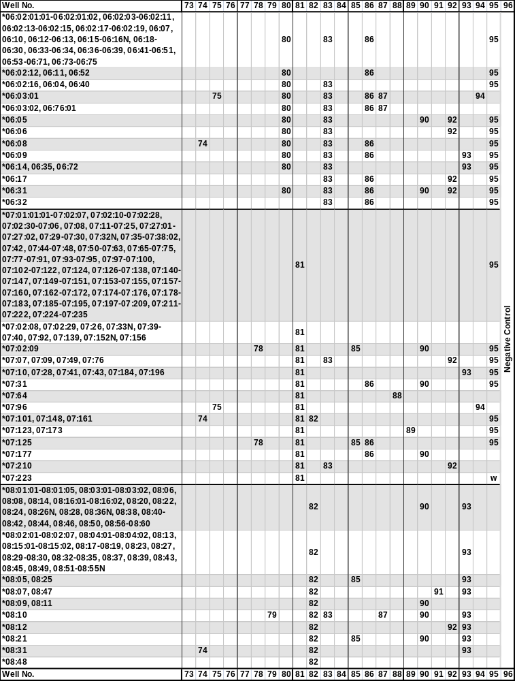
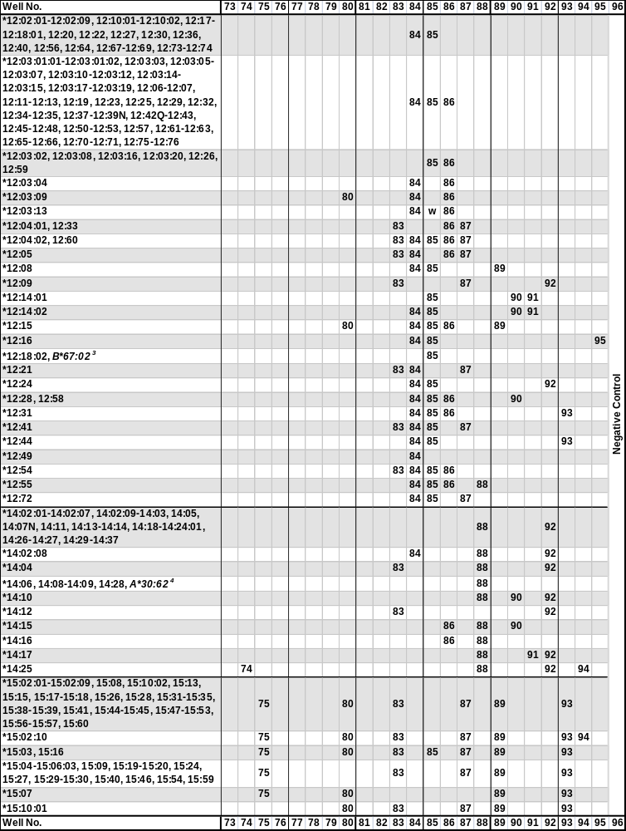

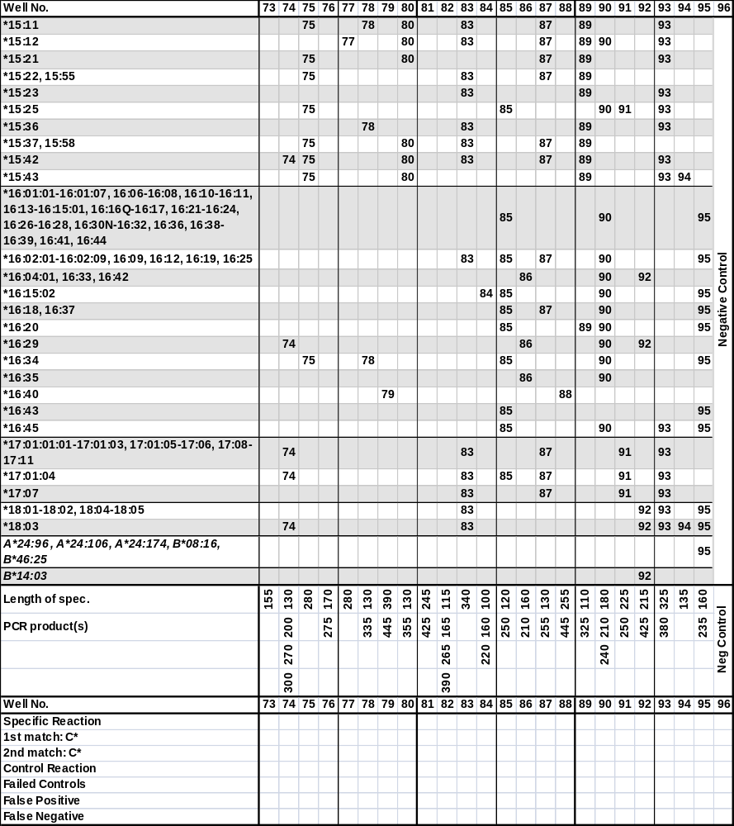

¹The sequence of the Cw*0101 allele has been shown to be identical to C*01:02:01.
The sequence of the Cw*0201 allele has been shown to be identical to C*02:02:02.
The sequence of the Cw*020204 allele has been shown to be identical to C*02:10.
The sequence of the Cw*021603 allele has has been shown to be identical to C*02:16:02.
The sequence of the Cw*0301 allele has been shown to be identical to C*03:04:01:01.
The sequence of the Cw*0402 allele has been shown to be identical to C*04:01:01:01.
The sequence of the Cw*0421 allele has been renamed to C*04:15:02.
The sequence of the Cw*0422 allele has been renamed to C*04:21.
The sequence of the Cw*0502 allele has been shown to be identical to C*05:09.
The sequence of the Cw*0601 allele has been shown to be identical to C*06:02:01:01.
The sequence of the Cw*060202 allele has been renamed to C*06:17.
The sequence of the Cw*0734 allele has been renamed to C*07:27:02.
The sequence of the Cw*1101 allele has been shown to be in error.
The sequence of the Cw*1201 allele has been shown to be identical to C*12:02:02.
The sequence of Cw*1301 has been shown to be in error.
The sequence of the Cw*1401 allele has been shown to be identical to C*14:02:01.
The sequence of the Cw*1501 allele has been shown to be identical to C*15:02:01.
The sequence of the Cw*1514 allele has been shown to be identical to C*15:10:02.
The sequence of the Cw*1603 allele has been shown to be identical to C*14:03.
The sequence of the Cw*16042 allele has been shown to be identical to C*16:04:01.
The sequence of the Cw*1605 allele has been shown to be identical to C*16:04:01.
⁵Primer mix 74 will for most C*02 alleles give rise to two specific PCR fragments.
Primer mix 76 will for most C*03 alleles give rise to two specific PCR fragments.
Primer mix 81 will for most C*07 alleles give rise to two specific PCR fragments.
Primer mix 82 will for most C*08 alleles give rise to multiple specific PCR fragments.
Primer mix 89 will for most C*15 alleles give rise to two specific PCR fragments.
²The C*01:05, 01:22, 01:35 and 01:36 and the B*54:18 alleles give rise to identical amplification patterns with the HLA-C low resolution primer set. These alleles are separated by the HLA-B low primer set.
³The C*14:06, 14:08-14:09 and 14:28 and the A*30:62 alleles give rise to identical amplification patterns with the HLA-C low resolution primer set. These alleles are separated by the HLA-A low primer set.
‘w’, might be weakly amplified.

Change in revision R01 compared to R00:
- The HLA-A*33:48 allele is amplified by primer mix 14. This has been corrected in the specificity and interpretation tables.
Changes in revision R02 compared to R01:
- Primer mix 43 does not amplify the B*15:101 allele. This has been corrected in the Specificity and Interpretation tables.
Change in revision R03 compared to R02:
- The HLA-A*03:01:03, 03:09, 03:23:01, 03:89, 03:108, 11:06, 11:18, 11:121, 24:28, 24:89, 26:03:01-26:03:02, 26:06, 26:07:02, 26:21, 26:30, 30:13, 30:16, 30:44, 30:46, 68:05, 68:15, 68:20 and 68:30 alleles are weakly amplified by primer mix 2. This has been corrected in the Specificity and Interpretation Tables.
Change in revision R04 compared to R03:
- In primer mix 5, the specific PCR product of 535 base pairs may be difficult to distinguish from the internal control band. A foot note has been added to the Specificity Table.
Change in revision R05 compared to R04:
- Primer mix 43 does not amplify the B*44:10 allele. This has been corrected in the Specificity and Interpretation Tables.
Change in revision R06 compared to R05:
- Primer mix 11 does not amplify the A*31:03 and A*66:15 alleles. This has been corrected in the Specificity and Interpretation tables.
Change in revision R07 compared to R06:
- Primer mix 28 amplifies the B*15:143, 35:19, 40:170, 44:07 and 50:07 alleles, and primer mix 50 amplifies the B*37:06:01 allele. Foot notes for these two primer mixes have been added to the Specificity Table.

